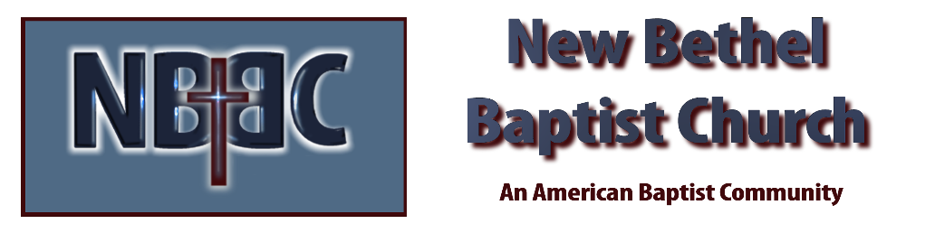

Sunday, July 23rd, 2023

Welcome & Announcements Julianne Thomas

Greeting the Fellowship

Prelude Jaci Greig

*Gathering Song Open Our Eyes, Lord #633

*Call to Worship Julianne Thomas
One: Come gather together here in the presence of Christ, who is our friend and healer.
Many: We have entered here, and in our worship together, we yearn for hope and comfort.
One: Let us reach to the heart of Jesus, who is our life.
Many: We encounter our Lord, who makes us whole.
One: He we are welcome and loved and cherished.
All: Here we are the people of God. Let us rejoice and give God praise.

*Invocation & Lord’s Prayer Julianne Thomas

Hymn Be Thou My Vision #562

Scripture Reading Psalm 139:1-12 Julianne Thomas
One: Hear what God is saying to the people.
All: Thanks be to God!
Worship Prayer Cares Chorus Pastor Dianna Cline

*Hymn Open My Eyes That I May See #563

Children and Youth Message Julianne Thomas

Scripture Reflection What’s Your Superpower? Pastor Dianna Cline
Genesis 28:10-19a

*Hymn of Response Standing on the Promises #410

Invitation to Respond Julianne Thomas

Offertory Jaci Greig *Doxology
*Prayer Julianne Thomas

Benediction Pastor Dianna Cline

Postlude Jaci Greig

CONTACT INFORMATION
New Bethel Baptist Church Website: www.newbethelbapt.org
8936 Southeastern Avenue E-mail: newbethelbapt@att.net Indianapolis, IN 46239 Wi-fi password: NBBC8624381
317-862-4381
Worship Music Copyright and Live-Streaming Permissions
All selections ©1997 Word/Integrity Used by Permission.
CCLI License #1631733

Live-Streaming: CCS, WorshipCast, License #10868

