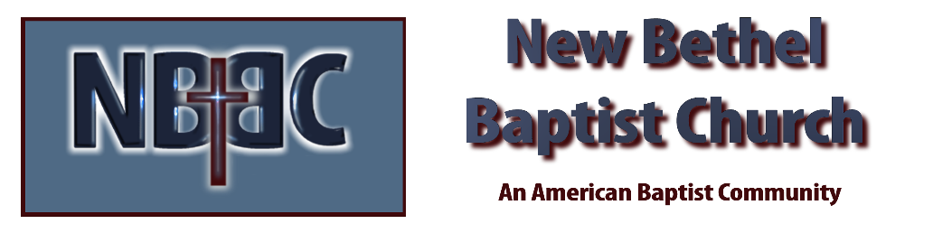

Sunday, July 30th, 2023

Welcome & Announcements Kevin Stone

Greeting the Fellowship

Prelude Jaci Greig

*Gathering Song Majesty #10

*Call to Worship (from: Liturgies from Below: 462 acts of worship) Kevin Stone
Many: God you are our refuge.
One: You are the shore in sight, you are hands that reach out, you are the ground on which to rest.
Many: God you are our strength.
One: You are the life we long for, you are the refusal to give up, you are the keys of home we carry with us.
Many: God you are our help in time of trouble.
One: We call on you from the ruins and the rubble, we call on you from the wildness and the deep,
All: We call on you to meet us in this place!

*Invocation & Lord’s Prayer Kevin Stone

Hymn Holy, Holy, Holy! #3

Scripture Reading Psalm 145:8-9, 14-21 Kevin Stone
One: Hear what God is saying to the people.
All: Thanks be to God!

Worship Prayer Cares Chorus Pastor Dianna Cline

*Hymn For the Beauty of the Earth #793

Scholarship Awards & Blessing of the Backpacks Ruth Ann Mills

Children and Youth Message Jim Winton

Scripture Reflection Matthew 13:31-33, 44-52 Pastor Dianna Cline
“Breaking News…The Kingdom of Heaven is…”

Hymn of Response Heaven Came Down #510

Invitation to Respond Kevin Stone

Offertory Jaci Greig *Doxology
*Prayer Kevin Stone

*Hymn of Invitation Seek Ye First #713

Benediction Pastor Dianna Cline

Postlude Jaci Greig

CONTACT INFORMATION
New Bethel Baptist Church Website: www.newbethelbapt.org
8936 Southeastern Avenue E-mail: newbethelbapt@att.net Indianapolis, IN 46239 Wi-fi password: NBBC8624381
317-862-4381
Worship Music Copyright and Live-Streaming Permissions
All selections ©1997 Word/Integrity Used by Permission.
CCLI License #1631733

Live-Streaming: CCS, WorshipCast, License #10868

