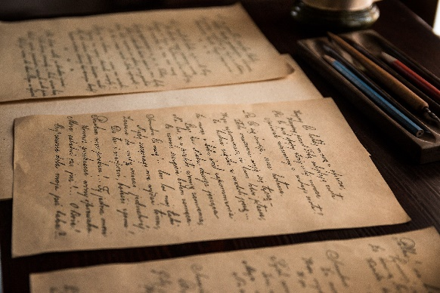

*Sunday, July 9th, 2023*

**Welcome** **& Announcements** Julianne Thomas

**Greeting the Fellowship**

**Prelude**  Jaci Greig

**\*Gathering Song** *Surely the Presence #219*

**\*Call to Worship**  Julianne Thomas

*One: God, you bring us together in this place. We come to be fed, to be renewed, to seek understanding.*

**Many: God, you challenge us in this place. We embrace the challenge, trusting that through the challenge we grow in faith.**

*One: God, you are revealed in this place – sometimes in shining glory, sometimes in tears and struggle.*

**Many: God as we worship in this place, refresh, renew and challenge us so that we would see your awesomeness.**

*One: We pray in Jesus’ name, as we strive to walk the path of discipleship.*

**All: Amen**

**\*Invocation & Lord’s Prayer**  Julianne Thomas

**Hymn** *Come, Thou Fount of Every Blessing #11*

**Scripture Reading** *Psalm 145:8-14* Julianne Thomas

*One: Hear what God is saying to the people.*

**All: Thanks be to God!**

**Worship Prayer** *Cares Chorus* Pastor Dianna Cline

**\*Hymn** *Blessed Assurance #572*

**Mission Moment** Liz Ballard

**Children and Youth Message** Julianne Thomas

**Scripture Reflection** ***Terms and Conditions*** Pastor Dianna Cline

*2 Thessalonians 3:6-13*

**\*Hymn of Response** *Trust and Obey #571*

**Invitation to Respond** Julianne Thomas

**Offertory**  Jaci Greig **\*Doxology**

**\*Prayer** Julianne Thomas

**Benediction** Pastor Dianna Cline

**Postlude**  Jaci Greig

**CONTACT INFORMATION**

New Bethel Baptist Church **Website:** www.newbethelbapt.org

8936 Southeastern Avenue **E-mail:** newbethelbapt@att.net Indianapolis, IN 46239 **Wi-fi password:** NBBC8624381

317-862-4381

**Worship Music Copyright and Live-Streaming Permissions**

All selections ©1997 Word/Integrity Used by Permission.

CCLI License #1631733

Live-Streaming: CCS, WorshipCast, License #10868