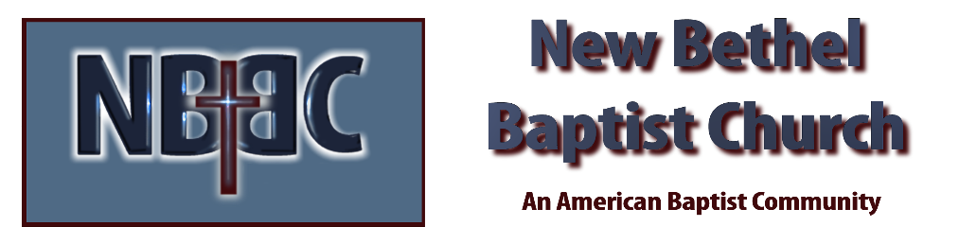

Sunday, August 13th, 2023

Welcome & Announcements Julianne Thomas

Greeting the Fellowship

Prelude Jaci Greig

*Gathering Song All Hail the Power of Jesus’ Name #43

*Call to Worship Julianne Thomas
One: He is the image of the invisible God, the firstborn over all creation. For by Him all things were created: things in heaven and on earth, visible and invisible, whether thrones or powers or rulers or authorities; all things were created by Him and for Him.
Many: He is King of kings and Lord of lords!
One: He is before all things, and I Him all things hold together. And He is the head of the body, the church; He is the beginning and the firstborn from among the dead, so that in everything He might have the supremacy.
Many: He is King of kings and Lord of Lords!
One: Therefore God exalted Him to the highest place and gave Him the name that is above very name.
Many: He is King of kings and Lord of lords!
One: At the name of Jesus every knee should bow, in heaven and on earth and under the earth.
Many: He is King of kings and Lord of Lords!
One: And every tongue confess that Jesus Christ is Lord to the glory of God the Father.
All: H E IS KING OF KINGS AND LORD OF LORDS!

*Invocation & Lord’s Prayer Julianne Thomas

Hymn Precious Lord, Take My Hand #684

Scripture Reading Psalm 85:8-13 Julianne Thomas
One: Hear what God is saying to the people.
All: Thanks be to God!

Worship Prayer Cares Chorus Pastor Dianna Cline

*Hymn Leaning on the Everlasting Arms #575

Children and Youth Message Julianne Thomas

Scripture Reflection Matthew 14:22-33 Pastor Dianna Cline
“Do you feel like your ship is sinking?”

Hymn of Response Trusting Jesus #578

Invitation to Respond Julianne Thomas

Offertory Jaci Greig *Doxology
*Prayer Julianne Thomas

Benediction Pastor Dianna Cline

Postlude Jaci Greig

CONTACT INFORMATION
New Bethel Baptist Church Website: www.newbethelbapt.org
8936 Southeastern Avenue E-mail: newbethelbapt@att.net Indianapolis, IN 46239 Wi-fi password: NBBC8624381
317-862-4381
Worship Music Copyright and Live-Streaming Permissions
All selections ©1997 Word/Integrity Used by Permission.
CCLI License #1631733

Live-Streaming: CCS, WorshipCast, License #10868

