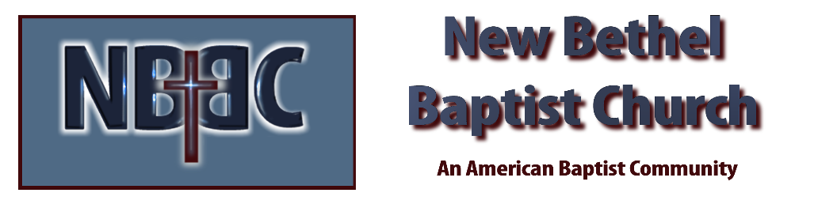

Sunday, August 20th, 2023

Welcome & Announcements Julianne Thomas

Greeting the Fellowship

Prelude Jaci Greig

*Gathering Song He Has Made Me Glad #214

*Call to Worship Julianne Thomas
One: Lord, make me an instrument of they peace.
Many: Where there is hatred, let me sow love;
One: Where there is injury, pardon;
Many: Where there is doubt, faith;
One: Where there is despair, hope;
Many: Where there is darkness, light;
One: Where there is sadness, joy. O divine Master, grant that I may not so much seek…
Many: To be consoled as to console,
One: To be understood as to understand,
Many: To be loved as to love;
One: for it is in giving that we receive;
Many: It is in pardoning that we are pardoned;
All: It is in dying that we are born to eternal life.

*Invocation & Lord’s Prayer Julianne Thomas

Hymn Just As I Am #684

Scripture Reading Isaiah 56:1, 6-8 Julianne Thomas
One: Hear what God is saying to the people.
All: Thanks be to God!

Worship Prayer Cares Chorus Pastor Dianna Cline

*Hymn It Is Well With My Soul #705

World Mission Offering Mission Moment Dick Juday

Children and Youth Message Julianne Thomas

Scripture Reflection Genesis 45:1-15 Pastor Dianna Cline
“Forgiveness”

Hymn of Response Change My Heart, O God #654

Invitation to Respond Julianne Thomas

Offertory Jaci Greig *Doxology
*Prayer Julianne Thomas

Benediction Pastor Dianna Cline

Postlude Jaci Greig

CONTACT INFORMATION
New Bethel Baptist Church Website: www.newbethelbapt.org
8936 Southeastern Avenue E-mail: newbethelbapt@att.net Indianapolis, IN 46239 Wi-fi password: NBBC8624381
317-862-4381
Worship Music Copyright and Live-Streaming Permissions
All selections ©1997 Word/Integrity Used by Permission.
CCLI License #1631733

Live-Streaming: CCS, WorshipCast, License #10868

