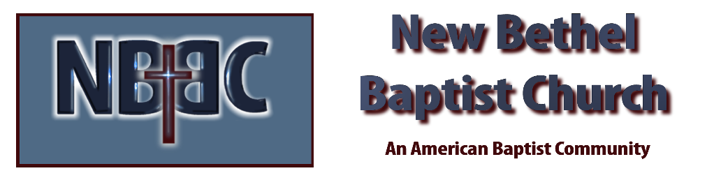

Sunday, August 27th, 2023

Welcome & Announcements Julianne Thomas

Greeting the Fellowship

Prelude Douglas Carter

*Gathering Song This is the Day #209

*Call to Worship Julianne Thomas
One: To You, O Lord, I lift up my soul; in You I trust, O my God.
Many: Do not let me be put to shame, nor let my enemies triumph over me. No one whose hope is in You will ever be put to shame.
One: Show me Your ways, O Lord, teach me Your paths; guide me in Your truth and teach me, for You are God, my Savior, and my hope is in You all day Long.
Many: Remember, O Lord, Your great mercy and love, for they are from of old. Remember not the sins of my youth and my rebellious ways; According to Your love, remember me, for You are good, O Lord.
One: All the ways of the Lord are loving and faithful for those who keep the demands of his covenant.
Many: For the sake of Your name, O Lord, forgive my iniquity, though it is great.
One: Who are they that fear the Lord?
Many: He will instruct them in the way chosen for them. They will spend their days in prosperity, and their descendants will inherit the land.
One: The Lord confides in those who fear Him;
Many: He makes his covenant known to them.
One: My eyes are ever on the Lord.
All: To You, O Lord, I lift up my soul; in You I trust, O my God.

*Invocation & Lord’s Prayer Julianne Thomas

Hymn Great Is Thy Faithfulness #139

Scripture Reading Psalm 138 Julianne Thomas
One: Hear what God is saying to the people.
All: Thanks be to God!

Worship Prayer Cares Chorus Pastor Dianna Cline

*Hymn O God, Our Help in Ages Past #686

Children and Youth Message Julianne Thomas

Scripture Reflection Psalm 124 Pastor Dianna Cline
“Spiritual Fugitives, Welcome”

Hymn of Response My Faith Looks Up to Thee #539

Invitation to Respond Julianne Thomas

Offertory Douglas Carter *Doxology
*Prayer Julianne Thomas

*Hymn of Invitation The Solid Rock #526
If you would like to make a decision to be baptized or join the church, we invite you forward during this hymn.

Benediction Pastor Dianna Cline

Postlude Douglas Carter

CONTACT INFORMATION
New Bethel Baptist Church Website: www.newbethelbapt.org
8936 Southeastern Avenue E-mail: newbethelbapt@att.net Indianapolis, IN 46239 Wi-fi password: NBBC8624381
317-862-4381
Worship Music Copyright and Live-Streaming Permissions
All selections ©1997 Word/Integrity Used by Permission.
CCLI License #1631733

Live-Streaming: CCS, WorshipCast, License #10868

