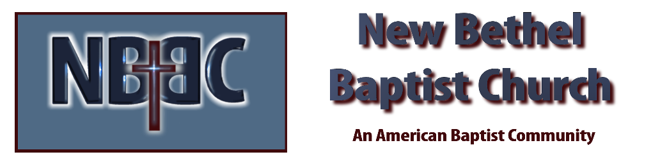

Communion Sunday, August 6th, 2023

Welcome & Announcements Julianne Thomas

Greeting the Fellowship

Prelude Jaci Greig

*Gathering Song Praise to the Lord the Almighty #210

*Call to Worship Julianne Thomas
One: Here we have gathered as God’s people, inspired by the Spirit...
Many: to witness more effectively, and to listen more deeply,
One: to speak more truthfully, and to live more peacefully,
Many: to love more energetically, and to teach more eloquently,
One: to pray more seriously, and to worship more enthusiastically,
All: to celebrate more joyfully, and to sing more faithfully,
One: to giver more generously, and to serve more compassionately.
All: Amen

*Invocation & Lord’s Prayer Julianne Thomas

Hymn Take My Life And Let It Be Consecrated #597

Scripture Reading Isaiah 55:1-7 Julianne Thomas
One: Hear what God is saying to the people.
All: Thanks be to God!

Worship Prayer Cares Chorus Pastor Dianna Cline

*Hymn Amazing Grace #343

Children and Youth Message Julianne Thomas
Scripture Reflection Matthew 14:13-21 Pastor Dianna Cline
Jesus’ Table

Hymn of Response Great is They Faithfulness #139

Invitation to Respond Julianne Thomas

Offertory Jaci Greig *Doxology
*Prayer Julianne Thomas

Communion Hymn Break Thou the Bread of Life #413

Communion Pastor Dianna Cline & Deacons

Benediction Blest Be the Tie That Binds Pastor Dianna Cline

Postlude Jaci Greig

CONTACT INFORMATION
New Bethel Baptist Church Website: www.newbethelbapt.org
8936 Southeastern Avenue E-mail: newbethelbapt@att.net Indianapolis, IN 46239 Wi-fi password: NBBC8624381
317-862-4381
Worship Music Copyright and Live-Streaming Permissions
All selections ©1997 Word/Integrity Used by Permission.
CCLI License #1631733

Live-Streaming: CCS, WorshipCast, License #10868

