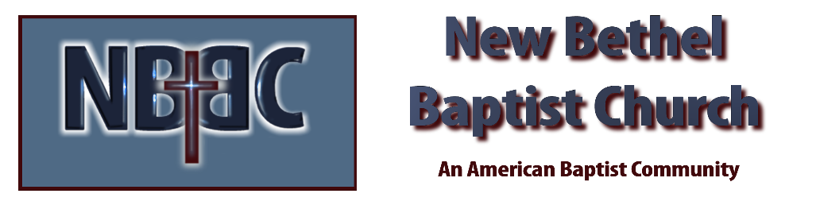
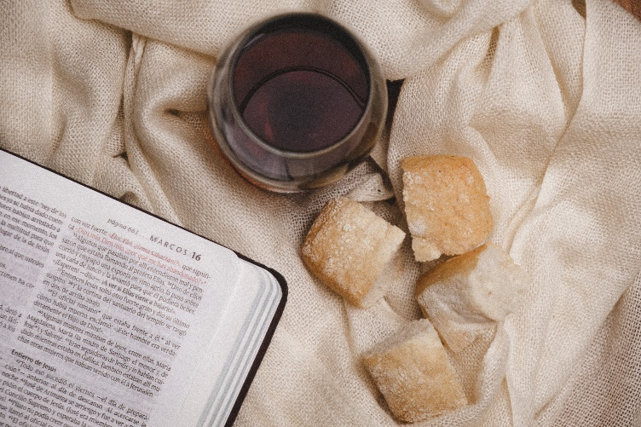
World Communion Sunday, October 1st, 2023

Welcome & Announcements Julianne Thomas

Greeting of the Fellowship

Prelude Jaci Greig

*Gathering Song O For a Thousand Tongues to Sing #21

*Call to Worship Julianne Thomas
One: Every good and perfect gift comes from God.
Many: Thanks be to God for the beauty and diversity of creation.
One: Thanks be to God for our ancestors of faith.
Many: Thanks be to God for Loving families and encouraging friends.
One: Thanks be to God for meaningful work.
Many: Thanks be to God for the variety of talents within the body of Christ.
One: Thanks be to God for freedom of conscience, speech, and worship.
Many: Thanks be to God for calling us to covenant relationship.
All: With thankful hearts let us worship and praise the Lord our God!

*Invocation & Lord’s Prayer Julianne Thomas

Hymn It Is Well With My Soul #705

Scripture Reading Psalm 25:1-9 Julianne Thomas
One: Hear what God is saying to the people.
All: Thanks be to God!

Worship Prayer Cares Chorus Pastor Dianna Cline

*Hymn I Give All to You #595

Children and Youth Message Julianne Thomas

Scripture Reflection Matthew 22:15-22 Pastor Dianna Cline
“Show Me the Money”

Hymn of Response We Are an Offering #678

Invitation to Respond Julianne Thomas

Offertory Jaci Greig *Doxology
*Prayer Julianne Thomas

Communion Hymn In Remembrance #461

Communion
One: Today we gather around God’s table from near and far.
Many: We are the People of God!
One: Though we differ in language, custom, and tradition.
Many: We are brothers and sisters in Christ!
One: For there is one Lord, one faith, and one baptism.
Many: We are one in God’s Spirit!
One: We are one and together we remember our Lord Jesus.
Many: For we are the people of Redemption!
One: He gave himself up for us, so we could be reconciled to God.
All: Come, let us worship the God of our Salvation!

Benediction Pastor Dianna Cline

Postlude Blest Be the Tie That Binds Jaci Greig

CONTACT INFORMATION
New Bethel Baptist Church Website: www.newbethelbapt.org
8936 Southeastern Avenue E-mail: newbethelbapt@att.net Indianapolis, IN 46239 Wi-fi password: NBBC8624381
317-862-4381
Worship Music Copyright and Live-Streaming Permissions
All selections ©1997 Word/Integrity Used by Permission.
CCLI License #1631733

Live-Streaming: CCS, WorshipCast, License #10868

