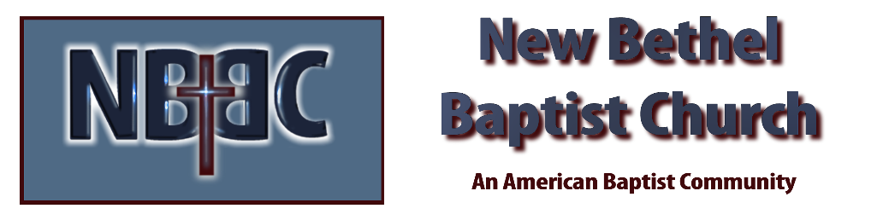

Sunday, September 17th, 2023

Welcome & Announcements Sue Winton

Greeting the Fellowship

Prelude Jaci Greig

*Gathering Song All Creatures of Our God and King #63 v.1,2,5

*Call to Worship Sue Winton
One: Come let us worship the Lord.
Many: God longs to give us the desires of our heart.
One: Let us bow down amid our preconceived, irreverent ideas.
Many: The law of the Lord is perfect, reviving the soul.
One: For God seeks to enter the into covenant with the children of all creation.
Many: Fill us, O Lord, with a sense of respect and awe, as you rouse yourself from your holy dwelling place to touch each of us…just as we are, where we are.
All: Praise your holy name.

*Invocation & Lord’s Prayer Sue Winton

Hymn Take Time to Be Holy #656

Scripture Reading Romans 14:1-12 Sue Winton
One: Hear what God is saying to the people.
All: Thanks be to God!

Worship Prayer Cares Chorus Pastor Dianna Cline

*Hymn A Shelter in the Time of Storm #693

Children and Youth Message Patty Dammann

Scripture Reflection Psalm 119:1-8 Pastor Dianna Cline
“The Expulsive Power of a New Affection”

Hymn of Response Wonderful Words of Life #406

Invitation to Respond Sue Winton

Offertory Jaci Greig *Doxology
*Prayer Sue Winton

Benediction Pastor Dianna Cline

Postlude Jaci Greig

CONTACT INFORMATION
New Bethel Baptist Church Website: www.newbethelbapt.org
8936 Southeastern Avenue E-mail: newbethelbapt@att.net Indianapolis, IN 46239 Wi-fi password: NBBC8624381
317-862-4381
Worship Music Copyright and Live-Streaming Permissions
All selections ©1997 Word/Integrity Used by Permission.
CCLI License #1631733

Live-Streaming: CCS, WorshipCast, License #10868

