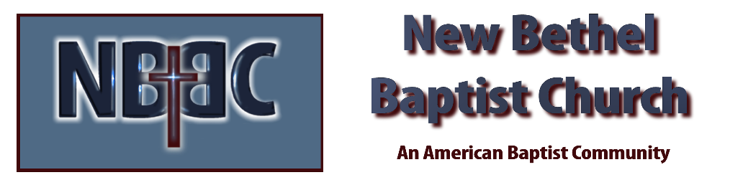
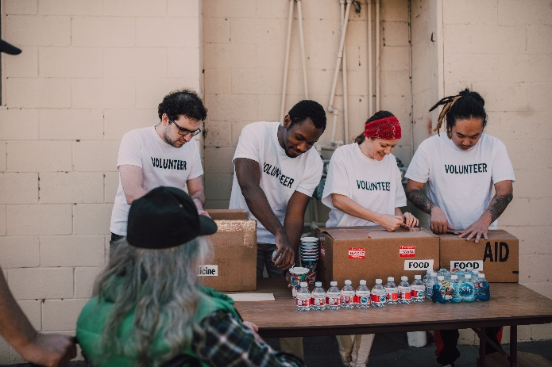
Sunday, September 17th, 2023

Welcome & Announcements Julianne Thomas

Prelude Jaci Greig

*Gathering Song All Creatures of Our God and King #63 v.1,2,5

*Call to Worship (“Jesus Calls Us from the Market Stalls”, out of Liturgies from Below) Julianne Thomas
One: Jesus calls us from the market stalls
Many: Not to leave our livelihood behind
One: Jesus calls us from the market stalls
Many: To fight the empire moving us out
One: Jesus calls us from the market stalls
Many: To bring us to a home that cannot be bought or sold
One: Jesus calls us from the market stalls
All: To stay and work together in faith. And to turn the tales of greed

*Invocation & Lord’s Prayer Julianne Thomas

Hymn Freely, Freely #436

Scripture Reading Psalm 145 1-9 Julianne Thomas
One: Hear what God is saying to the people.
All: Thanks be to God!

Worship Prayer Cares Chorus Pastor Dianna Cline

*Hymn We Are Called to Be God’s People #415

Children and Youth Message Julianne Thomas

Scripture Reflection Matthew 20:1-16 Pastor Dianna Cline
“The Key to 100% Satisfaction”

Hymn of Response Make Me a Blessing #670

Invitation to Respond Julianne Thomas

Offertory Jaci Greig *Doxology
*Prayer Julianne Thomas

Hymn of Invitation Give Me Jesus #554

Benediction Pastor Dianna Cline

Postlude Jaci Greig

CONTACT INFORMATION
New Bethel Baptist Church Website: www.newbethelbapt.org
8936 Southeastern Avenue E-mail: newbethelbapt@att.net Indianapolis, IN 46239 Wi-fi password: NBBC8624381
317-862-4381
Worship Music Copyright and Live-Streaming Permissions
All selections ©1997 Word/Integrity Used by Permission.
CCLI License #1631733

Live-Streaming: CCS, WorshipCast, License #10868

