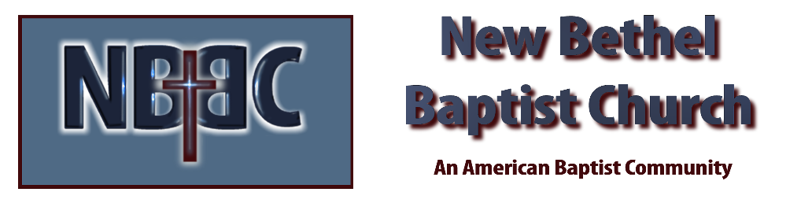

Communion Sunday, September 3rd, 2023

Welcome & Announcements Julianne Thomas

Greeting the Fellowship

Prelude Jaci Greig

*Gathering Song All Creatures of Our God and King #63 v.1,2,5

*Call to Worship Julianne Thomas
One: Love circles around,
Many: Joining hands, linking hearts,
One: Flowing from parent to child,
Many: From friend to friend to friend;
One: From one beloved to another.
Many: Love circles around,
One: Never giving up,
Many: Always reaching out.
One: Love circles around,
All: And God’s love embraces all.

*Invocation & Lord’s Prayer Julianne Thomas

Hymn I Love You with the Love of the Lord #422
The Bond of Love #423

Scripture Reading 1 Corinthians 13 Julianne Thomas
One: Hear what God is saying to the people.
All: Thanks be to God!

Worship Prayer Cares Chorus Pastor Dianna Cline

*Hymn The Servant Song #424 v.1-5

Children and Youth Message Julianne Thomas

Scripture Reflection Romans 12:9-21 Pastor Dianna Cline
“Let Your Love Be Genuine”

Hymn of Response They’ll Know We are Christians #429

Invitation to Respond Julianne Thomas

Offertory Jaci Greig *Doxology
*Prayer Julianne Thomas

*Communion Hymn Break Thou the Bread of Life #413

Communion Pastor Dianna and Deacons

Benediction Pastor Dianna Cline
Blest Be the Tie that Binds

Postlude Jaci Greig

CONTACT INFORMATION
New Bethel Baptist Church Website: www.newbethelbapt.org
8936 Southeastern Avenue E-mail: newbethelbapt@att.net Indianapolis, IN 46239 Wi-fi password: NBBC8624381
317-862-4381
Worship Music Copyright and Live-Streaming Permissions
All selections ©1997 Word/Integrity Used by Permission.
CCLI License #1631733

Live-Streaming: CCS, WorshipCast, License #10868

