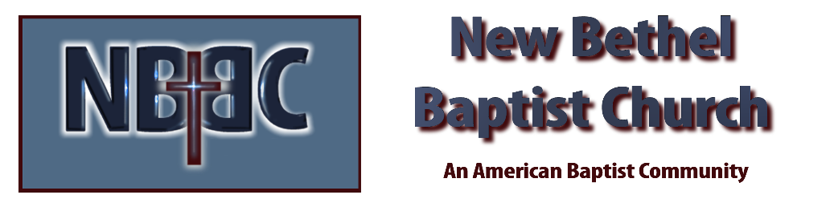
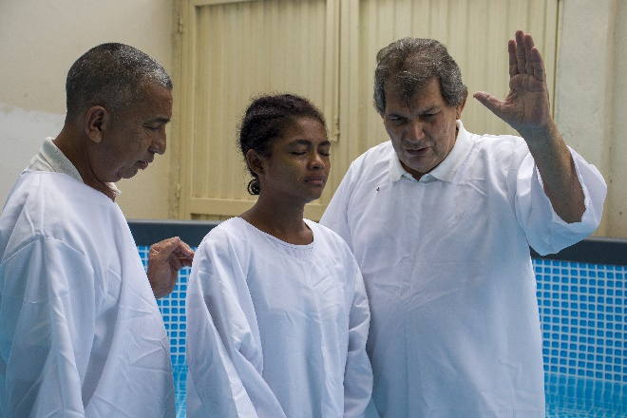
Sunday, October 22nd, 2023

Welcome & Announcements Julianne Thomas

Greeting of the Fellowship

Prelude Jaci Greig

*Call to Worship (Liturgies from Below 462 acts of Worship) Julianne Thomas
Unison: We have come together to praise God to whom we have belonged since the creation of the world, when water was created. WE have heard God’s voice ordering chaos with the Word of life, illuminating the darkness of an eternal night that saw light for the first time.

We come to thank God for being the water that purifies us and seals us in an eternal covenant, and to give all the glory to our creator who has always sustained us, even now.
God is our light.

May the whole creation adore him. Hallelujah. Amen

Baptism of Donna Carnes Pastor Dianna Cline

*Gathering Hymn Come Christians, Join to Sing #225

*Invocation & Lord’s Prayer (We use “sins/sinned”) Julianne Thomas

Hymn Beneath the Cross of Jesus #320

Scripture Reading Psalm 96 Julianne Thomas
One: Hear what God is saying to the people.
All: Thanks be to God!

Worship Prayer Cares Chorus Pastor Dianna Cline

*Hymn When I Survey the Wondrous Cross #321

Scripture Reflection Isaiah 64:1-9 Pastor Dianna Cline
“Garbology 101”

Hymn of Response O Happy Day! #498

Invitation to Respond Julianne Thomas

Offertory Jaci Greig *Doxology
*Prayer Julianne Thomas

Benediction Pastor Dianna Cline

Postlude Jaci Greig

CONTACT INFORMATION
New Bethel Baptist Church Website: www.newbethelbapt.org
8936 Southeastern Avenue E-mail: newbethelbapt@att.net Indianapolis, IN 46239 Wi-fi password: NBBC8624381
317-862-4381
Worship Music Copyright and Live-Streaming Permissions
All selections ©1997 Word/Integrity Used by Permission.
CCLI License #1631733

Live-Streaming: CCS, WorshipCast, License #10868

