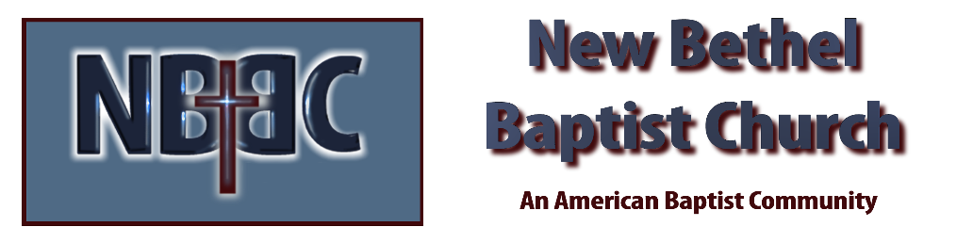

Sunday, October 29th, 2023

Welcome & Announcements Julianne Thomas

Greeting of the Fellowship

Prelude Jaci Greig

*Gathering Hymn Surely the Presence of the Lord Is in This Place #219

*Call to Worship Julianne Thomas
One: We come into the presence of the Holy God,
Many: Who may not be grasped,
One: But may be gazed upon;
Many: Who is not easily understood,
One: But is full of understanding;
Many: Who does not come at our beck and call,
One: But who is always near.
All: We gather as God’s children, in confident assurance that God is here.

*Invocation & Lord’s Prayer (We use “sins/sinned”) Julianne Thomas

Hymn Turn Your Eyes Upon Jesus #340

Scripture Reading Psalm 90 Julianne Thomas
One: Hear what God is saying to the people.
All: Thanks be to God!

Worship Prayer Cares Chorus Pastor Dianna Cline

*Hymn Open Our Eyes, Lord #633

Scripture Reflection Matthew 25:31-46 Pastor Dianna Cline
“Would You Know Jesus If You Saw Him?”

Hymn of Response Be Thou My Vision #562

Invitation to Respond Julianne Thomas

Offertory Jaci Greig *Doxology
*Prayer Julianne Thomas

*Hymn of Invitation Jesus Calls Us #592

Benediction Pastor Dianna Cline

Postlude Jaci Greig

CONTACT INFORMATION
New Bethel Baptist Church Website: www.newbethelbapt.org
8936 Southeastern Avenue E-mail: newbethelbapt@att.net Indianapolis, IN 46239 Wi-fi password: NBBC8624381
317-862-4381
Worship Music Copyright and Live-Streaming Permissions
All selections ©1997 Word/Integrity Used by Permission.
CCLI License #1631733

Live-Streaming: CCS, WorshipCast, License #10868

