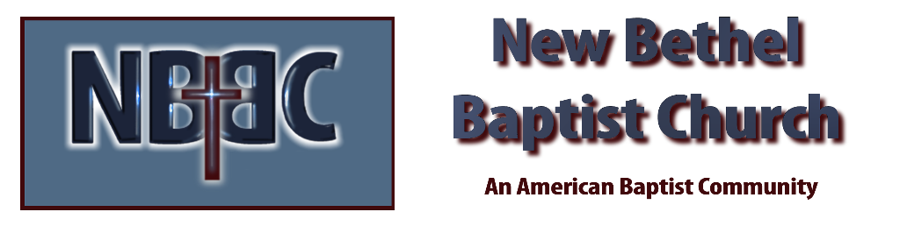

Sunday, October 8th, 2023

Welcome & Announcements Julianne Thomas

Greeting of the Fellowship

Prelude Rev. Judy Fackenthal

*Gathering Song We Have Come into His House #224

*Call to Worship Julianne Thomas
One: Doors open. Hearts ready, God beckons.
Many: Looking for a center point to life, for a union of all the scattered and torn edges.
One: May your soul find communion here.
Many: Searching for honesty, for a truth spoken in love.
One: May your faith be challenged here.
Many: Looking for a place to offer your time and talents.
One: May your spirit enrich this community.
Many: Searching for joy to blossom and hope to grow.
All: May our songs reach the heavens, touch our hearts and spread love into the world.

*Invocation & Lord’s Prayer Julianne Thomas

Hymn Praise Him! Praise Him! #12

Scripture Reading Psalm 19 Julianne Thomas
One: Hear what God is saying to the people.
All: Thanks be to God!

Worship Prayer Cares Chorus Pastor Dianna Cline

*Hymn My Faith Looks Up to Thee #539

Mission Moment & Children and Youth Message Julianne Thomas

Scripture Reflection Mark 12:38-44 Pastor Dianna Cline
“Going the Extra Mile”

Hymn of Response Take My Life, and Let it Be #597

Invitation to Respond Julianne Thomas

Offertory Rev. Judy Fackenthal *Doxology
*Prayer Julianne Thomas

Benediction Pastor Dianna Cline

Postlude Rev. Judy Fackenthal

CONTACT INFORMATION
New Bethel Baptist Church Website: www.newbethelbapt.org
8936 Southeastern Avenue E-mail: newbethelbapt@att.net Indianapolis, IN 46239 Wi-fi password: NBBC8624381
317-862-4381
Worship Music Copyright and Live-Streaming Permissions
All selections ©1997 Word/Integrity Used by Permission.
CCLI License #1631733

Live-Streaming: CCS, WorshipCast, License #10868

