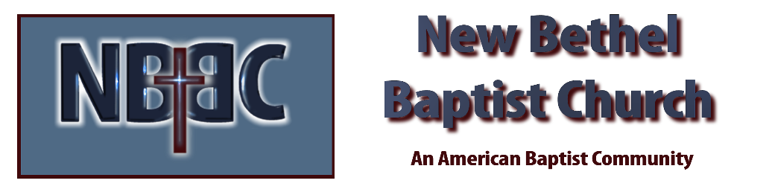

Sunday, November 12th, 2023

Welcome & Announcements Julianne Thomas

Greeting of the Fellowship

Prelude Jaci Greig

*Gathering Hymn Come, Let Us Worship and Bow Down #227

*Call to Worship (from 1 Thessalonians 4:13-14, 16-17) Julianne Thomas
One: We do not want you to be ignorant about those who fall asleep, or to grieve like the rest of humanity, who have no hope.
Many: We believe that Jesus died and rose again and so we believe that God will bring with Jesus those who have fallen asleep in Him.
One: For the Lord will come down from heaven, with a loud command, with the voice of the archangel and with the trumpet call of God, and the dead in Christ will rise first.
Many: After that, we who are still alive and are left will be caught up together with them in the clouds to meet the Lord in the air.
All: And so we will be with the Lord forever.

*Invocation & Lord’s Prayer (We use “sins/sinned”) Julianne Thomas

Hymn Soon and Very Soon #757

Scripture Reading Psalm 78:1-7 Julianne Thomas
One: Hear what God is saying to the people.
All: Thanks be to God!
Worship Prayer Pastor Dianna Cline
Prayer Song Cares Chorus
Prayer (a time will be given for you to call out your out your joys and concerns)

*Hymn Jesus Is Coming Again #753

Special Music Be Still My Soul Phil Morgan

Scripture Reflection Matthew 25:1-13 Pastor Dianna Cline
“Are you READY?”

*Hymn of Response Give Me Oil In My Lamp On the Screen

Invitation to Respond Julianne Thomas

Offertory Jaci Greig *Doxology
*Prayer Julianne Thomas

Benediction Pastor Dianna Cline

Postlude Phil Morgan

CONTACT INFORMATION
New Bethel Baptist Church Website: www.newbethelbapt.org
8936 Southeastern Avenue E-mail: newbethelbapt@att.net Indianapolis, IN 46239 Wi-fi password: NBBC8624381
317-862-4381
Worship Music Copyright and Live-Streaming Permissions
All selections ©1997 Word/Integrity Used by Permission.
CCLI License #1631733

Live-Streaming: CCS, WorshipCast, License #10868

