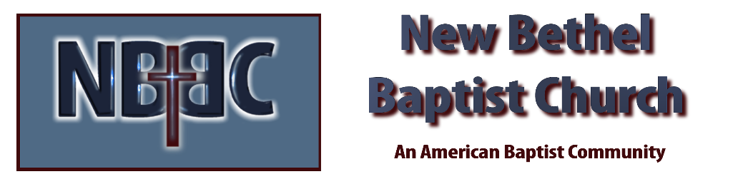

Sunday, November 19th, 2023

Welcome & Announcements Julianne Thomas

Greeting of the Fellowship

Prelude Jaci Greig

*Gathering Hymn As the Deer #548

*Call to Worship Julianne Thomas
One: Praise Christ,
Many: the peace of the living God.
One: Praise Christ,
Many: the light of the living God.
One: Praise Christ,
Many: the love of the living God.
One: Praise Christ,
Many: the hope of the living God.
One: Praise Christ,
Many: the joy of the living God.
One: Praise Christ,
Many: for he has given us life!
One: Praise Christ,
All: here now and in our worship!

*Invocation & Lord’s Prayer (We use “sins/sinned”) Julianne Thomas

Hymn More About Jesus #560

Scripture Reading Psalm 123 Julianne Thomas
One: Hear what God is saying to the people.
All: Thanks be to God!

Worship Prayer Pastor Dianna Cline
Prayer Song Cares Chorus
Prayer (a time will be given for you to call out your out your joys and concerns)

*Hymn Be Thou My Vision #562

Mission Moment Jaci Greig
Scripture Reflection Luke 17:11-19 Pastor Dianna Cline
“What is Your Vision?”

*Hymn of Response Footsteps of Jesus #685
Invitation to Respond Julianne Thomas

Offertory Jaci Greig *Doxology
*Prayer Julianne Thomas

Benediction Pastor Dianna Cline

Postlude Jaci Greig

CONTACT INFORMATION
New Bethel Baptist Church Website: www.newbethelbapt.org
8936 Southeastern Avenue E-mail: newbethelbapt@att.net Indianapolis, IN 46239 Wi-fi password: NBBC8624381
317-862-4381
Worship Music Copyright and Live-Streaming Permissions
All selections ©1997 Word/Integrity Used by Permission.
CCLI License #1631733

Live-Streaming: CCS, WorshipCast, License #10868

