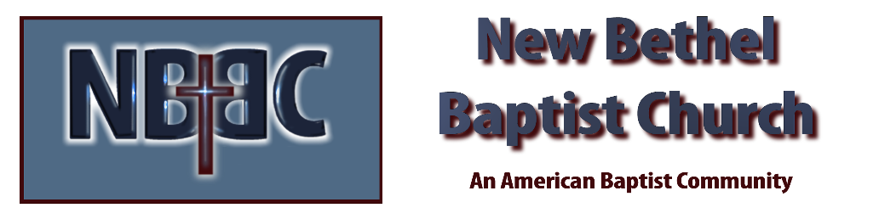
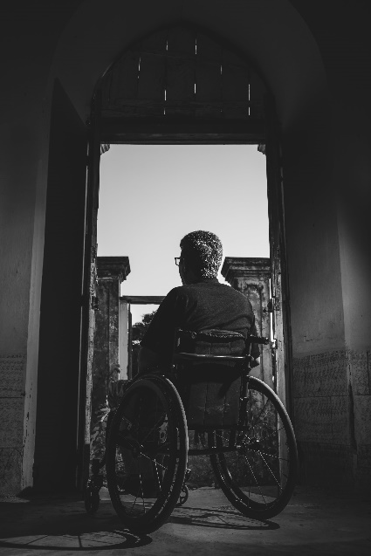
Sunday, November 26th, 2023

Welcome & Announcements Phil Morgan

Greeting of the Fellowship

Prelude Jaci Greig

*Gathering Hymn Holy, Holy #69

*Call to Worship (From Liturgies from Below 462 acts of worship) Phil Morgan
One: Come!
Many: Come into the place where God listens!
One: Where you need no money, no status, no fine clothes!
Many: Come as you are
One: Broken, whole; Sick, well
Many: Satisfied or with deep needs
One: Come to sing, Come to cry
Many: Come to hear, Come to see
One: Come and be ready or…
Many: Come and be made ready
One: We are here
All: God is here too

*Invocation & Lord’s Prayer (We use “sins/sinned”) Phil Morgan

Hymn God Will Make a Way #704

Scripture Reading Psalm 95:1-7 Phil Morgan
One: Hear what God is saying to the people.
All: Thanks be to God!

Worship Prayer Julianne Thomas
Prayer Song Cares Chorus
Prayer One: God of Grace Many: Hear our prayer

*Hymn Have Faith in God #536

Scripture Reflection Matthew 9:2-8 Julianne Thomas
“The Inclusiveness of Jesus”

*Hymn of Response No, Not One! #609
Invitation to Respond Phil Morgan

Offertory Jaci Greig *Doxology
*Prayer Phil Morgan

*Hymn of Invitation Just As I Am #488

Benediction Julianne Thomas

Postlude Jaci Greig

CONTACT INFORMATION
New Bethel Baptist Church Website: www.newbethelbapt.org
8936 Southeastern Avenue E-mail: newbethelbapt@att.net Indianapolis, IN 46239 Wi-fi password: NBBC8624381
317-862-4381
Worship Music Copyright and Live-Streaming Permissions
All selections ©1997 Word/Integrity Used by Permission.
CCLI License #1631733

Live-Streaming: CCS, WorshipCast, License #10868

