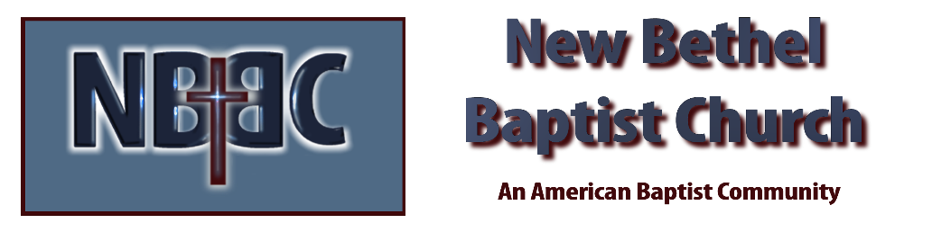

Communion Sunday, November 5th, 2023

Welcome & Announcements Julianne Thomas

Greeting of the Fellowship

Prelude Jaci Greig

*Gathering Hymn Come, Let Us Worship and Bow Down #227

*Call to Worship Julianne Thomas
One: In the midst of meaninglessness,
Many: You call us to meaning, O God.
One: In the midst of divisiveness,
Many: You call us to community through Christ.
One: Out of our brokenness,
Many: You call us to wholeness and new life in the Spirit.
One: In praise and thanksgiving, let us worship God.

*Invocation & Lord’s Prayer (We use “sins/sinned”) Julianne Thomas

Hymn Cleanse Me #657

Scripture Reading Micah 3:5-12 Julianne Thomas
One: Hear what God is saying to the people.
All: Thanks be to God!
Worship Prayer Pastor Dianna Cline
Prayer Song Cares Chorus
Prayer (a time will be given for you to call out your out your joys and concerns)

*Hymn Pass Me Not #633

Children and Youth Message Julianne Thomas

Scripture Reflection Matthew 23:1-12 Pastor Dianna Cline
“Are You Humble?”

*Hymn of Response Just as I Am #488

Invitation to Respond Julianne Thomas

Offertory Jaci Greig *Doxology
*Prayer Julianne Thomas

Communion Hymn Let Us Break Bread Together #460

Communion Pastor Dianna Cline & Deacons

Benediction Blest Be the Tie That Binds Pastor Dianna Cline

Postlude Jaci Greig

CONTACT INFORMATION
New Bethel Baptist Church Website: www.newbethelbapt.org
8936 Southeastern Avenue E-mail: newbethelbapt@att.net Indianapolis, IN 46239 Wi-fi password: NBBC8624381
317-862-4381
Worship Music Copyright and Live-Streaming Permissions
All selections ©1997 Word/Integrity Used by Permission.
CCLI License #1631733

Live-Streaming: CCS, WorshipCast, License #10868

