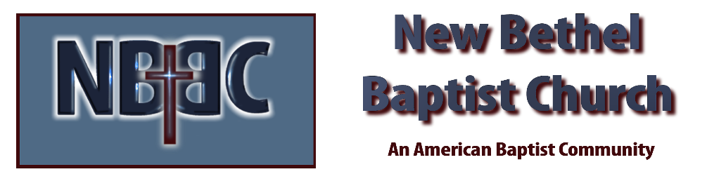
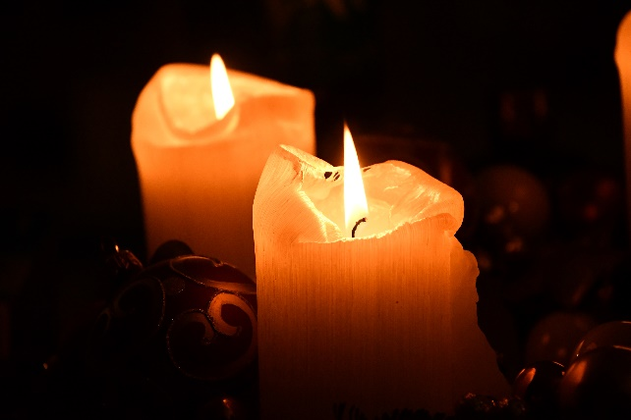
Second Sunday in Advent, December 10th, 2023

Welcome & Announcements Julianne Thomas

Greeting of the Fellowship

Prelude Jaci Greig

*Gathering Hymn O Come, O Come Emmanuel #245

*Call to Worship (Adapted from “Instruments of Your Peace” by Don Moen) Julianne Thomas
One: Holy, God, make us instruments of Your peace.
Many: Where there is hatred, we will show God’s love.
One: Creator of All, make us instruments of Your peace.
Many: Where there is injury, we will never judge.
One: Divine Parent, make us instruments of Your peace.
Many: Where there is darkness, we will shine God’s light.
One: Blessed Trinity, make us instruments of Your peace.
Many: Where there is sadness, we will bear their grief.
One: Beloved One, make us instruments of Your peace.
All: To the millions crying for relief, we will be Your instruments of Peace.

Advent Moment Jaci Greig & Wilma Waters

Hymn Lo! How a Rose E’er Blooming #255

Worship Prayer Pastor Dianna Cline
Prayer Song Cares Chorus
Prayer (During the prayer you will have the opportunity to call concerns and praises)

*Hymn Peace Like a River #750

Scripture Reflection Psalm 85:1-2, 8-13 Pastor Dianna Cline
“Peace”

*Hymn of Response Wonderful Peace #184

Invitation to Respond Julianne Thomas

Offertory Jaci Greig *Doxology
*Prayer Julianne Thomas

Benediction Pastor Dianna Cline

Postlude Jaci Greig

CONTACT INFORMATION
New Bethel Baptist Church Website: www.newbethelbapt.org
8936 Southeastern Avenue E-mail: newbethelbapt@att.net Indianapolis, IN 46239 Wi-fi password: NBBC8624381
317-862-4381
Worship Music Copyright and Live-Streaming Permissions
All selections ©1997 Word/Integrity Used by Permission.
CCLI License #1631733

Live-Streaming: CCS, WorshipCast, License #10868

