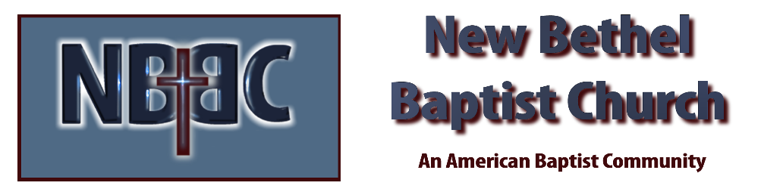

Third Sunday in Advent, December 17th, 2023

Welcome & Announcements Adrianne Hunter

Greeting of the Fellowship

Prelude Jaci Greig

*Gathering Hymn O Come, O Come Emmanuel #245

*Call to Worship (by Harry Disher) Adrianne Hunter
One: Sing praises to God on high, for glorious are God’s works.
Many: Sing praises to the ends of the earth.
One: Shout and sing for joy, O people of God.
Many: For great is the Holy One in our midst, blessed is the One who comes to dwell among us.

Advent Moment Phil & Pat Morgan

Hymn Rejoice in the Lord Always #745

Worship Prayer Pastor Dianna Cline
Prayer Song Cares Chorus
Prayer (During the prayer you will have the opportunity to call concerns and praises)

*Hymn O Thou Joyful, O Thou Wonderful #282

Scripture Reflection Psalm 126 Pastor Dianna Cline
“Joy”

*Hymn of Response He Keeps Me Singing #746

Invitation to Respond Adrianne Hunter

Offertory Jaci Greig *Doxology
*Prayer Adrianne Hunter

Benediction Pastor Dianna Cline

Postlude Jaci Greig

CONTACT INFORMATION
New Bethel Baptist Church Website: www.newbethelbapt.org
8936 Southeastern Avenue E-mail: newbethelbapt@att.net Indianapolis, IN 46239 Wi-fi password: NBBC8624381
317-862-4381
Worship Music Copyright and Live-Streaming Permissions
All selections ©1997 Word/Integrity Used by Permission.
CCLI License #1631733

Live-Streaming: CCS, WorshipCast, License #10868

