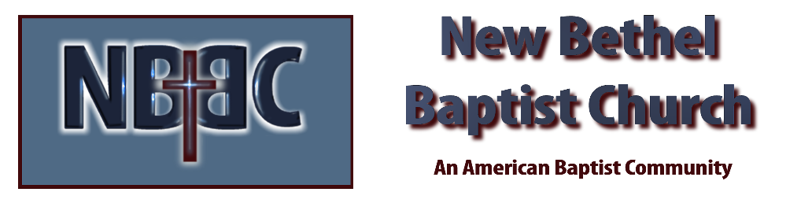

Fourth Sunday in Advent, December 24th, 2023

Welcome & Announcements Julianne Thomas

Greeting of the Fellowship

Prelude Jaci Greig

*Gathering Hymn O Come, O Come Emmanuel #245

*Call to Worship (by Anonymous) Julianne Thomas
One: God’s love for us strong and warm,
Many: Opening our eyes to the wonders all around us.
One: God’s love for us is wild and freeing,
Many: Opening us to new ways, new paths, new relationships.
One: God’s love for us is compassionate and gentle,
Many: Comforting us in our pain, weeping with us in our distress.
One: God’s love for us is holy and challenging,
Many: Calling us to risk ourselves for the sake of God and others.
One: God’s love for us is sure and certain. It cannot fail and will never end.
Many: We give thanks to God for the gift of love and made known to us in Jesus Christ!

Advent Moment Melody and Patrick Lynch

Hymn The Bond of Love #423

Worship Prayer Pastor Dianna Cline
Prayer Song Cares Chorus
Prayer (During the prayer you will have the opportunity to call concerns and praises)

*Hymn Of The Faither’s Love Begotten #240

Scripture Reflection Psalm 89:1-4, 19-26 Pastor Dianna Cline
“Love”

*Hymn of Response More Love to Thee #79

Invitation to Respond Julianne Thomas

Offertory Jaci Greig *Doxology
*Prayer Julianne Thomas

Benediction Pastor Dianna Cline

Postlude Jaci Greig

CONTACT INFORMATION
New Bethel Baptist Church Website: www.newbethelbapt.org
8936 Southeastern Avenue E-mail: newbethelbapt@att.net Indianapolis, IN 46239 Wi-fi password: NBBC8624381
317-862-4381
Worship Music Copyright and Live-Streaming Permissions
All selections ©1997 Word/Integrity Used by Permission.
CCLI License #1631733

Live-Streaming: CCS, WorshipCast, License #10868

