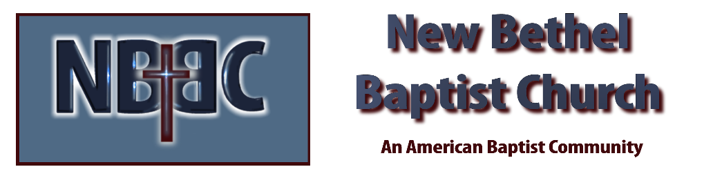

First Sunday in Advent, December 4th, 2023

Welcome & Announcements Julianne Thomas

Greeting of the Fellowship

Prelude Jaci Greig

*Gathering Hymn O Come, O Come Emmanuel #245

*Call to Worship (Adapted from “The Light” in The Celebration Hymnal) Julianne Thomas
One: In the beginning was the Word,
Pastor: And the Word was with God,
One: And the Word was God.
Many: He was in the beginning with God.
One: All things were made through Him, and without Him nothing was made that was made.
Many: In Him was life, and the life was the light of men.
Pastor: And the light shines in the darkness, and the darkness did not comprehend it.
One: There was a man sent from God, whose name was John. This man came for a witness, to bear witness of the light, that all through Him might believe.
Pastor: He was not that light, but was sent to bear witness of that light.
One: That was the true light which gives light to every man who comes into the world.
Many: He was in the world, and the world was made through Him, and the world did not know Him.
One: He came to His own, and His own did not receive Him.
Many: But as many as received Him, to them He gave the right to become children of God, even to those who believe in His name.
Pastor: These were born not of blood, not of the will of the flesh, not of the will of man, but of God.
All: And the word became flesh and dwelt among us, and we beheld His glory-
the glory as of the only begotten of the Father, full of grace and truth.

Advent Moment Patty Dammann and Nancy Starke

Hymn Come Thou Long-Expected Jesus #244

Worship Prayer Pastor Dianna Cline
Prayer Song Cares Chorus
Prayer (During the prayer you will have the opportunity to call concerns and praises)

*Hymn Praise the One Who Breaks the Darkness #293

Scripture Reflection Psalm 80:1-7, 17-19 Pastor Dianna Cline
“Hope”

*Hymn of Response Thy Word #184

Invitation to Respond Julianne Thomas

Offertory Jaci Greig *Doxology
*Prayer Julianne Thomas

*Communion Hymn Come to the Table #464

Communion Pastor Dianna Cline & Deacons

Benediction Julianne Thomas

Postlude Jaci Greig

CONTACT INFORMATION
New Bethel Baptist Church Website: www.newbethelbapt.org
8936 Southeastern Avenue E-mail: newbethelbapt@att.net Indianapolis, IN 46239 Wi-fi password: NBBC8624381
317-862-4381
Worship Music Copyright and Live-Streaming Permissions
All selections ©1997 Word/Integrity Used by Permission.
CCLI License #1631733

Live-Streaming: CCS, WorshipCast, License #10868

