# Welcome to New Bethel Baptist Church

*An American Baptist Congregation*

***We are blessed by your presence!***

**GUEST AND MEMBERS:** If you have questions or would like more information about New Bethel, please feel free to contact the church office. Thank you!

**\*\*\*\*\*\***

Connect With Us

 New Bethel Baptist.Wanamaker

 nbbc.wanamaker

 New Bethel Baptist Church Wanamaker

## ****** CONTACT INFORMATION

New Bethel Baptist Church **Website:** [www.newbethelbapt.org](http://www.newbethelbapt.org/) 8936 Southeastern Avenue **E-mail:** [newbethelbapt@att.net](mailto:newbethelbapt@att.net)

Indianapolis, IN 46239 **Wi-fi password:** NBBC8624381

317-862-4381

Pastor Dianna Cline

Julianne Thomas, Minister of Administration Pianist Jaci Greig

**Worship Music Copyright and Live-Streaming Permissions**

**All selections ©1997 Word/Integrity Used by Permission.**

**CCLI License #1631733**

**Live-Streaming: CCS, WorshipCast, License #10868**

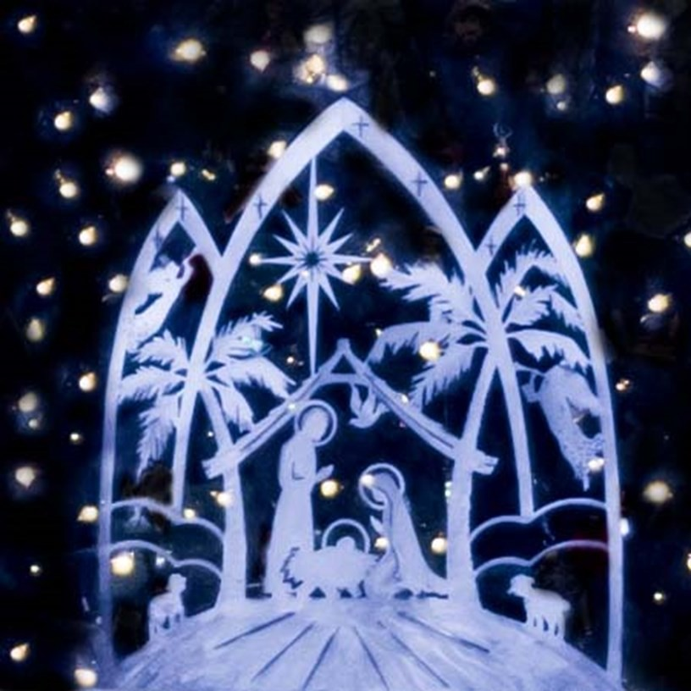

***“And while they were there, the time came for her baby to be born. She gave birth to her firstborn son. She wrapped him snugly in strips of cloth and laid him in a manger, because there was no lodging available for them.”***

***Luke 2:6-7 NLT***

# Welcome to New Bethel Baptist Church

*Christmas Eve, December 24, 2022*

**Prelude** Jaci Greig

**\*Gathering Songs** *O Come, O Come, Emmanuel #245*

*O Come All Ye Faithful #249*

**\*Call To Worship** Julianne Thomas

*One: The people walking in darkness have seen a great light.*

## Many: A Light has dawned on those living in the land of the shadow of death.

*One: For to us, a child is born, unto us a son is given.*

## Many: He is called Wonderful Counselor, Mighty God, Everlasting Father, Prince of Peace.

*One: Today we remember that God came to be with us through Jesus the Christ.*

## All: Tonight we celebrate God’s choice to forever be present with us!

**\*Invocation** Pastor Dianna Cline

**Scripture Reading** Luke 2:1-8 Jim Winton

1 And it came to pass in those days *that* a decree went out from Caesar Augustus that all the world should be registered. 2 This census first took place while Quirinius was governing Syria. 3 So all went to be registered, everyone to his own city.

4 Joseph also went up from Galilee, out of the city of Nazareth, into Judea, to the city of David, which is called Bethlehem, because he was of the house and lineage of

David, 5 to be registered with Mary, his betrothed wife, who was with child.

6 So it was, that while they were there, the days were completed for her to be deliv-

ered. 7 And she brought forth her firstborn Son, and wrapped Him in swaddling cloths, and laid Him in a manger, because there was no room for them in the inn. Glory in the Highest

8 Now there were in the same country shepherds living out in the fields, keeping watch over their flock by night.

## Lighting of First Candle

**Prayer** Pastor Dianna Cline

**Hymns** *While Shepherds Watched Their Flocks #272*

**Scripture Reading** Luke 2:9-12 Julianne Thomas 9 And behold, an angel of the Lord stood before them, and the glory of the Lord

shone around them, and they were greatly afraid. 10 Then the angel said to

them, “Do not be afraid, for behold, I bring you good tidings of great joy which will be to all people.

11 For there is born to you this day in the city of David a Savior, who is Christ the

Lord. 12 And this *will be the sign to you: You will find a Babe wrapped in swaddling cloths, lying in a manger.”*

|  |  |  |
| --- | --- | --- |
| **Lighting of Second Candle**  **Prayer** |  | Pastor Dianna Cline |
| **Hymn** | *Angels From the Realms of Glory* | *#259* |
| **Scripture Reading** | Luke 2:13-15 | Bonita Hopkins |

13 And suddenly there was with the angel a multitude of the heavenly host praising God and saying:

14 “Glory to God in the highest, And on earth peace, goodwill toward men!”

15 So it was, when the angels had gone away from them into heaven, that the shep- herds said to one another, “Let us now go to Bethlehem and see this thing that has come to pass, which the Lord has made known to us.”

## Lighting of Third Candle

**Offering**

Special Music *Breath of Heaven* Julianne Thomas & Jaci Greig

**Hymn** *Angels We Have Heard on High #278*

**Scripture Reading** Luke 2:16-18 Jim Winton 16 And they came with haste and found Mary and Joseph, and the Babe lying in a

manger. 17 Now when they had seen *Him, they made widely known the saying which*

*was told them concerning this Child. 18 And all those who heard it marveled at those things which were told them by the shepherds.*

## Lighting of the Fourth Candle

**Prayer** Pastor Dianna Cline

**Hymn** *Away in a Manger #261*

***Scripture Reading*** Luke 2:19-20 Bonita Hopkins

19 But Mary kept all these things and pondered *them in her heart. 20 Then the shep- herds returned, glorifying and praising God for all the things that they had heard and seen, as it was told them.*

***Hymn*** *Go Tell It on the Mountain #258 O Holy Night #285*

**Prayer** Pastor Dianna Cline

**\*Hymn** *Silent Night*

(As you pass the light, hold the lit candle upright and let the unlit candle tip to be lit)

Verse 1 Silent night, holy night, All is calm, all is bright.

Round yon virgin mother and Child, Holy Infant so ten-der and mild,

Sleep in heavenly peace, Sleep in heavenly peace.

Verse 2 Silent night, holy night, Shepherds quake at the sight.

Glories stream from heaven afar; Heavenly host sing alleluia.

Christ the Savior is born! Christ the Savior is born!

Verse 4 Silent night, holy night, Song of God, love’s pure light Radiant beams from Thy holy face,

With the dawn of redeeming grace,

Jesus, Lord, at Thy birth, Jesus, Lord, at Thy birth.

**\*Benediction** Pastor Dianna Cline