
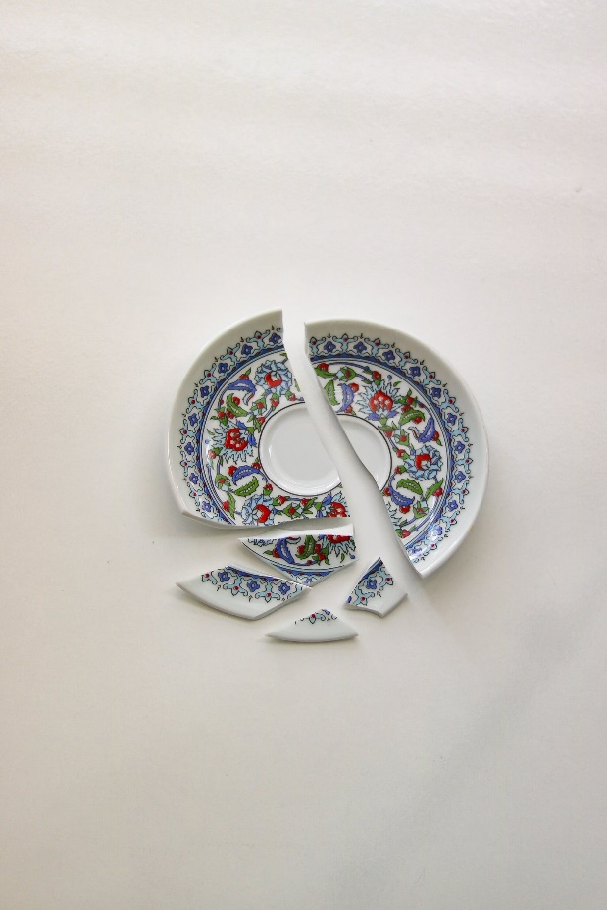
Epiphany Sunday, Communion Sunday, January 7th, 2023

Welcome & Announcements Julianne Thomas

Greeting of the Fellowship

Prelude Jaci Greig

*Gathering Hymn Praise to the Lord, the Almighty #210

*Call to Worship Julianne Thomas
One: God, whose love is pouring over us, welcomes us here today.
Many: Praise be to God!
One: God, whose healing power is ready to bind up our wounds, welcomes us here today.
Many: Praise be to God!
One: God, whose transforming presence offers us hope and peace, welcomes us here today.
All: Praise be to God who loves, heals and restores us. AMEN.

Invocation & Lord’s Prayer (We use “sins”) Julianne Thomas

Hymn Sing We Now of Christmas #275

Scripture Reading Matthew 2:1-12 Julianne Thomas
One: Hear what God is saying to the people
Many: Thanks be to God!

Worship Prayer Pastor Dianna Cline
Prayer Song Cares Chorus
Prayer (During the prayer you will have the opportunity to call concerns and praises)

*Hymn We Three Kings #288

Youth & Children’s Message Julianne Thomas

Scripture Reflection Acts 19:1-7 Pastor Dianna Cline
“Brokenness”

Hymn of Response Blessed Assurance #572

Invitation to Respond Julianne Thomas

Offertory Jaci Greig *Doxology
*Prayer Julianne Thomas

Communion Hymn A Communion Hymn for Christmas #287

Communion Pastor Dianna Cline & Deacons

Benediction Pastor Dianna Cline

Postlude Blest Be the Tie That Binds Jaci Greig

CONTACT INFORMATION
New Bethel Baptist Church Website: www.newbethelbapt.org
8936 Southeastern Avenue E-mail: newbethelbapt@att.net Indianapolis, IN 46239 Wi-fi password: NBBC8624381
317-862-4381
Worship Music Copyright and Live-Streaming Permissions
All selections ©1997 Word/Integrity Used by Permission.
CCLI License #1631733

Live-Streaming: CCS, WorshipCast, License #10868

