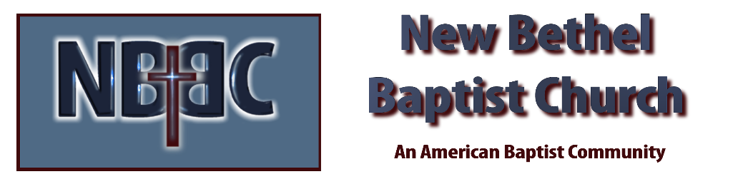

Sunday, April 21st, 2024

Welcome & Announcements Phil Morgan
.
Greeting of the Fellowship

Prelude Jaci Greig

*Gathering Hymn We Have Come into His House #224

*Call to Worship Phil Morgan
One: Rejoice people of God! In Christ there is hope and peace.
Many: But how can we rejoice? The world is full of hunger, agony, conflict and pain.
One: Rejoice people of God! For in God there is justice and love. God is the source of everything.
Many: But how? The problems are big and the injustice overwhelming.
One: Rejoice people of God! For in you Christ live and all things are possible.
All: Rejoice! We are God’s tools of justice and love. Through God we can work for peace and feed one another.

Invocation & Lord’s Prayer (We use “sins”) Phil Morgan

Hymn The Solid Rock #526

Scripture Reading Psalm 23 Phil Morgan
One: Hear what God is saying to the people
Many: Thanks be to God!

Worship Prayer Pastor Dianna Cline
Prayer Song Cares Chorus
Prayer (During the prayer you will have the opportunity to call out concerns and praises)

*Hymn All Hail the Power of Jesus’ Name #43

Scripture Reflection Acts 4:5-12 Pastor Dianna Cline
“Charge! Clear! Contact! Ker-pow!

*Hymn of Response Victory in Jesus #353

Invitation to Respond Phil Morgan

Offertory Jaci Greig *Doxology
*Prayer Phil Morgan
If you are seeking bap'sm, to become a member at New Bethel, or would like someone to pray
with you, you are invited to come forward during this hymn.
If you are seeking bap'sm, to become a member at New Bethel, or would like someone to pray
with you, you are invited to come forward during this hymn.

Benediction Pastor Dianna Cline

Postlude Jaci Greig

CONTACT INFORMATION
New Bethel Baptist Church Website: www.newbethelbapt.org
8936 Southeastern Avenue E-mail: newbethelbapt@att.net Indianapolis, IN 46239 Wi-fi password: NBBC8624381
317-862-4381
Worship Music Copyright and Live-Streaming Permissions
All selections ©1997 Word/Integrity Used by Permission.
CCLI License #1631733

Live-Streaming: CCS, WorshipCast, License #10868

