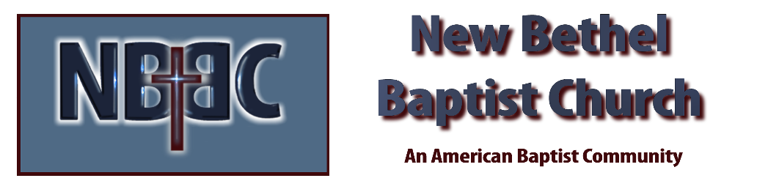
Sunday, May 26th, 2024

Welcome & Announcements Ruth Ann Mills
Greeting of the Fellowship
Prelude Jaci Greig
*Gathering Hymn Give to Our God Immortal Praise #112

*Call to Worship The King of Glory Ruth Ann Mills
One: The earth is the Lord’s, and everything in it; the world, and all who live in it.
Many: For he founded it upon the seas and established it upon the waters.
One: Who may ascend the hill of the Lord? Who may stand in His holy place?
Many: He who has clean hands and a pure heart, who does not lift up his soul to an idol or swear by what is false.
One: He will receive blessings from the Lord.
Many: and vindication from God, his Savior.
One: Such is the generation of those who seek Him – who see your face, O God of Jacob.
Many: Lift up your heads, O you gates; Be lifted up, you ancient doors, that the King of glory may come in.
One: Who is this King of Glory?
Many: The Lord, strong and mighty;
One: The Lord, mighty in battle.
Many: Lift up your heads, O you gates; Lift them up, you ancient doors that the King of glory may come in.
One: Who is he, this King of glory?
Many: The Lord Almighty – He is the King of glory.

*Invocation & Lord’s Prayer (We use “sins”) Ruth Ann Mills

Hymn Holy, Holy, Holy! Lord God Almighty #3

Scripture Reading Psalm 29 Ruth Ann Mills
One: Hear what God is saying to the people
Many: Thanks be to God!

Worship Prayer Pastor Dianna Cline
Prayer Song Cares Chorus
Prayer (During the prayer you will have the opportunity to call out concerns and praises)

*Hymn Immortal, Invisible, God Only Wise #33

Scripture Reflection Isaiah 6:1-13 Pastor Dianna Cline
“Is God Radically Present”

*Hymn of Response Come, Holy Spirit #382

Invitation to Respond

Offertory Jaci Greig *Doxology
*Prayer Ruth Ann Mills
If you are seeking bap'sm, to become a member at New Bethel, or would like someone to pray
with you, you are invited to come forward during this hymn.
If you are seeking bap'sm, to become a member at New Bethel, or would like someone to pray
with you, you are invited to come forward during this hymn.

Benediction Pastor Dianna Cline
Postlude Jaci Greig

CONTACT INFORMATION
New Bethel Baptist Church Website: www.newbethelbapt.org
8936 Southeastern Avenue E-mail: newbethelbapt@att.net Indianapolis, IN 46239 Wi-fi password: NBBC8624381
317-862-4381
Worship Music Copyright and Live-Streaming Permissions
All selections ©1997 Word/Integrity Used by Permission.
CCLI License #1631733

Live-Streaming: CCS, WorshipCast, License #10868

