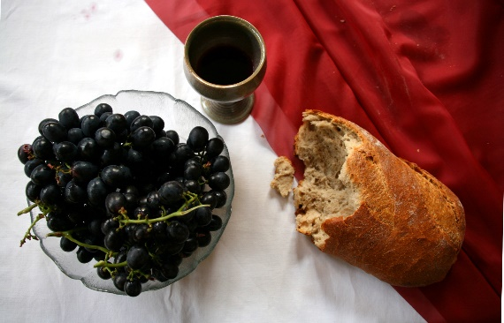

*Sunday, June 2nd, 2024*

**Welcome** **& Announcements** Adrianne Hunter

**Greeting of the Fellowship**

**Prelude** Jaci Greig

**\*Gathering Hymn** *We Have Come Into His House #224*

**\*Call to Worship** Adrianne Hunter

*Leader: Give thanks to the Lord for God is good*

**People: God’s steadfast love endures forever.**

*Leader: When we call upon the Lord, God comes to us to save us.*

**People: God’s amazing love endures forever.**

*Leader: When our hearts are troubled, God comes to us with blessings.*

**People: God’s extravagant love endures forever.**

*Leader: When our spirits struggle and are discouraged, God comes to us with healing.*

**People: God’s generous love endures forever.**

*Leader: When our lives are overwhelmed, God comes as a courageous Spirit.*

**People: God’s forgiving love endures forever.**

**Mission Moment** Liz Ballard

**\*Invocation & Lord’s Prayer** (We use “sins”) Adrianne Hunter

**Hymn** *God Will Take Care of You #692*

**Scripture Reading** Psalm 81:1-10 Adrianne Hunter

One: Hear what God is saying to the people

**Many: Thanks be to God!**

**Worship Prayer**  Pastor Dianna Cline

**Prayer Song** *Cares Chorus*

**Prayer** (During the prayer you will have the opportunity to call out concerns and praises)

**\*Hymn** Standing on the Promises #410

(verses 1,2,& 5)

**Scripture Reflection** 2 Corinthians 4:5-12 Pastor Dianna Cline

***“Living Life in the New Normal”***

**\*Hymn of Response** *Precious Lord Take My Hand #684*

**Invitation to Respond** Adrianne Hunter

**Offertory** Jaci Greig **\*Doxology**

**\*Prayer** Adrianne Hunter

If you are seeking bap'sm, to become a member at New Bethel, or would like someone to pray

with you, you are invited to come forward during this hymn.

If you are seeking bap'sm, to become a member at New Bethel, or would like someone to pray

with you, you are invited to come forward during this hymn.

**Communion Hymn** *Come, Share the Lord* #462

**We Gather at the Communion Table** Pastor Dianna and Deacons

**Benediction Hymn** Blest Be the Tie

**Benediction**  Pastor Dianna Cline

**Postlude** Jaci Greig

**CONTACT INFORMATION**

New Bethel Baptist Church **Website:** www.newbethelbapt.org

8936 Southeastern Avenue **E-mail:** newbethelbapt@att.net Indianapolis, IN 46239 **Wi-fi password:** NBBC8624381

317-862-4381

**Worship Music Copyright and Live-Streaming Permissions**

All selections ©1997 Word/Integrity Used by Permission.

CCLI License #1631733

Live-Streaming: CCS, WorshipCast, License #10868