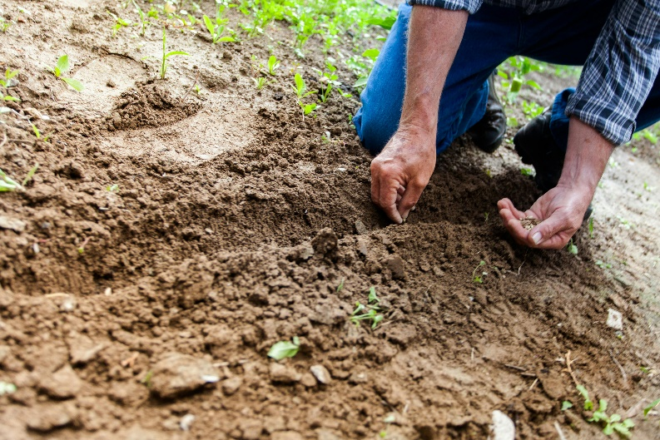

*Sunday, June 9th, 2024*

**Welcome** **& Announcements** Adrianne Hunter

**Greeting of the Fellowship**

**Prelude** Jaci Greig

**\*Gathering Hymn** *All Hail the Power of Jesus’ Name #43*

**\*Call to Worship** Adrianne Hunter

*Leader: Winter, spring, summer, fall. In every season, you are worthy of worship.*

**People: In good times and bad, sorrow and joy. In all circumstances, you are worthy of worship**

*Leader: When we feel distant from you or can feel the warmth of your love surrounding us. Whatever our feelings, you are worthy of worship*

**People: Today, in all things, you are worthy of worship. And so, we come to you as we are, and give you our worship and praise.**

**All: This is all for you. Receive our worship.**

**\*Invocation & Lord’s Prayer** (We use “sins”) Adrianne Hunter

**Hymn** *Be Thou My Vision #562*

**Scripture Reading** *Psalm 130*  Adrianne Hunter

One: Hear what God is saying to the people

**Many: Thanks be to God!**

**Worship Prayer**  Pastor Dianna Cline

**Prayer Song** *Cares Chorus*

**Prayer** (During the prayer you will have the opportunity to call out concerns and praises)

**\*Hymn** *Open My Eyes that I may See #563*

**Scripture Reflection** Mark 3:20 - 35 Pastor Dianna Cline

***“Emotions”***

**\*Hymn of Response** *O to be like Thee! #551*

**Invitation to Respond** Adrianne Hunter

**Offertory** Jaci Greig **\*Doxology**

**\*Prayer** Adrianne Hunter

**Worship Music Copyright and Live-Streaming Permissions**

All selections ©1997 Word/Integrity Used by Permission.

CCLI License #1631733

Live-Streaming: CCS, WorshipCast, License #10868

If you are seeking bap'sm, to become a member at New Bethel, or would like someone to pray

with you, you are invited to come forward during this hymn.

If you are seeking bap'sm, to become a member at New Bethel, or would like someone to pray

with you, you are invited to come forward during this hymn.

**Benediction**  Pastor Dianna Cline

**Postlude** Jaci Greig

**CONTACT INFORMATION**

New Bethel Baptist Church **Website:** www.newbethelbapt.org

8936 Southeastern Avenue **E-mail:** newbethelbapt@att.net Indianapolis, IN 46239 **Wi-fi password:** NBBC8624381

317-862-4381