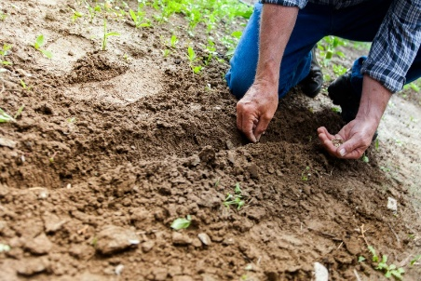

*Sunday, July 21st, 2024*

**Welcome** **& Announcements** Jim Winton

**Greeting of the Fellowship**

**Prelude** Jaci Greig

**\*Gathering Hymn**  *This is the Day #209*

*(Sing 2 times)*

**\*Call to Worship** Jim Winton

*One: This is the day our God is making.*

**All: Let us rejoice.**

*One: This is the time when God is present.*

**All: Let us be open.**

*One: This is the moment when forgiveness flows and life is renewed.*

**All: Let us sing.**

**\*Invocation & Lord’s Prayer** (We use “sins”) Jim Winton

**Hymn**  *Peace Like a River #750*

**Scripture Reading** *Mark 6:30-34, 53-56* Jim Winton

One: Hear what God is saying to the people

**Many: Thanks be to God!**

**Worship Prayer**  Pastor Dianna Cline

**Prayer Song** *Cares Chorus*

**Prayer** (During the prayer you will have the opportunity to call out concerns and praises)

**\*Hymn** *Pass Me Not #489*

**Scripture Reflection** *Ephesians 2:11-22*  Pastor Dianna Cline

***“A Formula for Forgiveness”***

**\*Hymn of Response** *Just as I am #488*

**Invitation to Respond** Jim Winton

**Offertory** Jaci Greig **\*Doxology**

**\*Prayer** Jim Winton

If you are seeking bap'sm, to become a member at New Bethel, or would like someone to pray

with you, you are invited to come forward during this hymn.

If you are seeking bap'sm, to become a member at New Bethel, or would like someone to pray

with you, you are invited to come forward during this hymn.

**Benediction**  Pastor Dianna Cline

**Postlude** Jaci Greig

**CONTACT INFORMATION**

New Bethel Baptist Church **Website:** www.newbethelbapt.org

8936 Southeastern Avenue **E-mail:** newbethelbapt@att.net Indianapolis, IN 46239 **Wi-fi password:** NBBC8624381

317-862-4381

**Worship Music Copyright and Live-Streaming Permissions**

All selections ©1997 Word/Integrity Used by Permission.

CCLI License #1631733

Live-Streaming: CCS, WorshipCast, License #10868