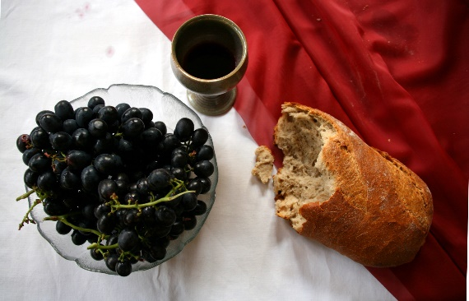

*Sunday, July 7th, 2024*

**Welcome** **& Announcements** Jim Winton

**Greeting of the Fellowship**

**Prelude** Dr. Christina Romero

**\*Gathering Hymn** *We Bring the Sacrifice of Praise #213*

*(Sing Twice)*

**\*Call to Worship** Jim Winton *Leader: We have been called together as the body of Christ.*

**People: We are one body, though we have many members.**

*Leader: Each part gets its meaning from the body as a whole, and not the other way around.*

**People: But not all members have the same function; we have different gifts.**

*Leader: God calls us to use these gifts generously, maturely and cheerfully to build up the body of Christ.*

**People: Together we present ourselves in service to God and each other.**

*Leader: Let us worship God!*

**\*Invocation & Lord’s Prayer** (We use “sins”) Jim Winton

**Hymn**  *Here I am, Lord #589*

**Scripture Reading** Ezekiel 2:1-5 Jim Winton

One: Hear what God is saying to the people

**Many: Thanks be to God!**

**Worship Prayer**  Pastor Dianna Cline

**Prayer Song** *Cares Chorus*

**Prayer** (During the prayer you will have the opportunity to call out concerns and praises)

**\*Hymn** *Wonderful Words of Life* #406

**Scripture Reflection** Mark 6:1-13 Pastor Dianna Cline

***“Many Rays”***

**\*Hymn of Response** *Take My Life, Lead Me Lord #664*

**Invitation to Respond** Jim Winton

**Offertory** Dr. Christina Romero **\*Doxology**

**\*Prayer** Jim Winton

If you are seeking bap'sm, to become a member at New Bethel, or would like someone to pray

with you, you are invited to come forward during this hymn.

If you are seeking bap'sm, to become a member at New Bethel, or would like someone to pray

with you, you are invited to come forward during this hymn.

**Communion Hymn** *In Remembrance*  #461

**We Gather at the Communion Table** Pastor Dianna and Deacons

**Benediction Hymn** Blest Be the Tie

**Benediction**  Pastor Dianna Cline

**Postlude** Dr. Christina Romero

**CONTACT INFORMATION**

New Bethel Baptist Church **Website:** www.newbethelbapt.org

8936 Southeastern Avenue **E-mail:** newbethelbapt@att.net Indianapolis, IN 46239 **Wi-fi password:** NBBC8624381

317-862-4381

**Worship Music Copyright and Live-Streaming Permissions**

All selections ©1997 Word/Integrity Used by Permission.

CCLI License #1631733

Live-Streaming: CCS, WorshipCast, License #10868