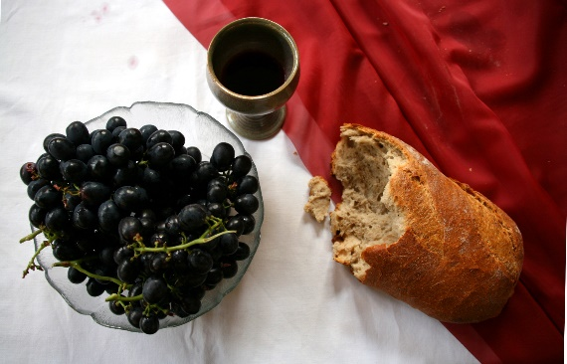

*Sunday, Augus t4th, 2024*

**Welcome** **& Announcements** Phil Morgan

**Greeting of the Fellowship**

**Prelude** Mary Collins

**\*Gathering Hymn***Let’s Just Praise the Lord #18*

**\*Call to Worship** Phil Morgan

*Leader: Let all who hunger for God come to God’s holy hill!*

**People: Blessed are those whose desire is for the Lord; let us lift our hearts and voices in thanksgiving.**

*Leader: Let all who thirst for God enter the temple of the Lord.*

**People: Blessed are those who worship in spirit and in truth. Let us worship God with prayer and praise!**

**\*Invocation & Lord’s Prayer** (We use “sins”) Phil Morgan

**Hymn**  *To God Be the Glory #56*

**Scripture Reading**  Psalm 78:23-29 Phil Morgan

One: Hear what God is saying to the people

**Many: Thanks be to God!**

**Worship Prayer**  Pastor Dianna Cline

**Prayer Song** *Cares Chorus*

**Prayer** (During the prayer you will have the opportunity to call out concerns and praises)

**\*Hymn**  *I must Tell Jesus #636*

**Scripture Reflection** John 6:24-35 Pastor Dianna Cline

***“Diets”***

**\*Hymn of Response** *Come Share the Lord #462*

**Invitation to Respond** Phil Morgan

**Offertory** Mary Collins **\*Doxology**

**\*Prayer** Phil Morgan

If you are seeking bap'sm, to become a member at New Bethel, or would like someone to pray

with you, you are invited to come forward during this hymn.

If you are seeking bap'sm, to become a member at New Bethel, or would like someone to pray

with you, you are invited to come forward during this hymn.

**Communion Hymn** *Come to the Table* #464

**We Gather at the Communion Table** Pastor Dianna and Deacons

**Benediction Hymn** Blest Be the Tie

**Benediction**  Pastor Dianna Cline

**Postlude** Mary Collins

**CONTACT INFORMATION**

New Bethel Baptist Church **Website:** www.newbethelbapt.org

8936 Southeastern Avenue **E-mail:** newbethelbapt@att.net Indianapolis, IN 46239 **Wi-fi password:** NBBC8624381

317-862-4381

**Worship Music Copyright and Live-Streaming Permissions**

All selections ©1997 Word/Integrity Used by Permission.

CCLI License #1631733

Live-Streaming: CCS, WorshipCast, License #10868