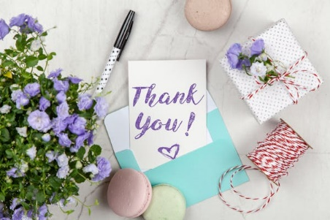

*Sunday, August 18th, 2024*

**Welcome** **& Announcements** Phil Morgan

**Greeting of the Fellowship**

**Prelude** Jaci Greig

**\*Gathering Hymn**  *Great is Thy Faithfulness  #139*

**\*Call to Worship** Phil Morgan

*Leader:  O God, with gratitude we come to this place of hallowed ground.*

**People:  Here we have come to be comforted after national disasters and personal losses.**

*Leader:  Here we have come to celebrate the joy of love, and the blessing of our children.*

**People:  We have come to hear your Word as we worship together.**

*Leader:  How grateful we are for what this sacred space has been.*

**All:  We gather for worship with the prayer that it shall always be.**

**\*Invocation & Lord’s Prayer** (We use “sins”) Phil Morgan

**Hymn** *Now Thank We all our God #788*

**Scripture Reading** *Psalm 34:9-14* Phil Morgan

One: Hear what God is saying to the people

**Many: Thanks be to God!**

**Worship Prayer**  Pastor Dianna Cline

**Prayer Song** *Cares Chorus*

**Prayer** (During the prayer you will have the opportunity to call out concerns and praises)

**\*Hymn** *Count Your Blessings #786*

**Scripture Reflection** *Ephesians 5:15-20*  Pastor Dianna Cline

***“Do we really have to give thanks for everything?”***

**\*Hymn of Response** *Jesus, We Just Want to Thank You  #791*

**Invitation to Respond** Phil Morgan

**Offertory** Jaci Greig **\*Doxology**

**\*Prayer** Phil Morgan

If you are seeking bap'sm, to become a member at New Bethel, or would like someone to pray

with you, you are invited to come forward during this hymn.

If you are seeking bap'sm, to become a member at New Bethel, or would like someone to pray

with you, you are invited to come forward during this hymn.

**Benediction**  Pastor Dianna Cline

**Postlude** Jaci Greig

**CONTACT INFORMATION**

New Bethel Baptist Church **Website:** www.newbethelbapt.org

8936 Southeastern Avenue **E-mail:** newbethelbapt@att.net Indianapolis, IN 46239 **Wi-fi password:** NBBC8624381

317-862-4381

**Worship Music Copyright and Live-Streaming Permissions**

All selections ©1997 Word/Integrity Used by Permission.

CCLI License #1631733

Live-Streaming: CCS, WorshipCast, License #10868