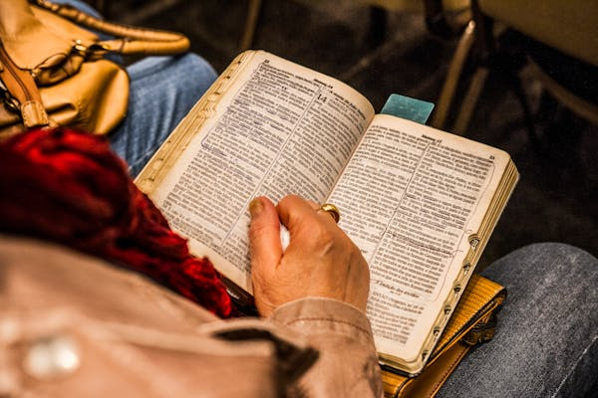

*Sunday, August 25th, 2024*

**Welcome** **& Announcements** Phil Morgan

**Greeting of the Fellowship**

**Prelude** Jaci Greig

**\*Gathering Hymn** *Glorify Thy Name #9*

**\*Call to Worship** Phil Morgan

*Leader: People of God, listen! Wisdom calls, and understanding raises her voice!*

**People: We gather to grow in wisdom and understanding, to hear God’s word for us.**

*Leader: She stands at roadside and cries to her people to take instruction.*

**People: Let us pay attention; let us worship God!**

**\*Invocation & Lord’s Prayer** (We use “sins”) Phil Morgan

**Hymn** *A Mighty Fortress is Our God #151*

**Scripture Reading** *Psalm 34:15-22* Phil Morgan

One: Hear what God is saying to the people

**Many: Thanks be to God!**

**Worship Prayer**  Pastor Dianna Cline

**Prayer Song** *Cares Chorus*

**Prayer** (During the prayer you will have the opportunity to call out concerns and praises)

**Mission Moment**

**\*Hymn**  Wonderful Words of Life   *#406*

**Scripture Reflection** *John 6:56-69*  Pastor Dianna Cline

***“Tips to Jumpstart your Reading the Bible”***

**\*Hymn of Response** *Thy Word #184*

**Invitation to Respond** Phil Morgan

**Offertory** Jaci Greig **\*Doxology**

**\*Prayer** Phil Morgan

If you are seeking bap'sm, to become a member at New Bethel, or would like someone to pray

with you, you are invited to come forward during this hymn.

If you are seeking bap'sm, to become a member at New Bethel, or would like someone to pray

with you, you are invited to come forward during this hymn.

**Benediction**  Pastor Dianna Cline

**Postlude** Jaci Greig

**CONTACT INFORMATION**

New Bethel Baptist Church **Website:** www.newbethelbapt.org

8936 Southeastern Avenue **E-mail:** newbethelbapt@att.net Indianapolis, IN 46239 **Wi-fi password:** NBBC8624381

317-862-4381

**Worship Music Copyright and Live-Streaming Permissions**

All selections ©1997 Word/Integrity Used by Permission.

CCLI License #1631733

Live-Streaming: CCS, WorshipCast, License #10868