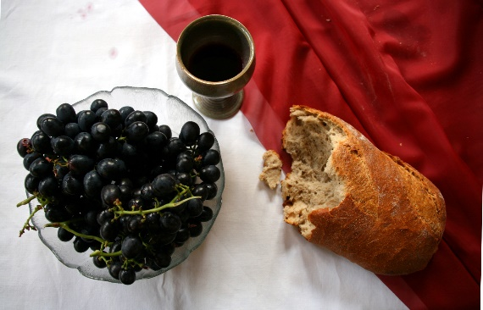

*Sunday, September 1st, 2024*

**Welcome** **& Announcements** Phil Morgan

**Greeting of the Fellowship**

**Prelude** Jaci Greig

**\*Gathering Hymn** *Oh How I love Jesus #92*

**\*Call to Worship** Phil Morgan

*One: A gift of a new day,*

**All: Unlived, untried, ready to be opened.**

*One: A new day with surprising miracles;*

**All: With love to be given,**

*One: Kindness to be shared*

**All: And peace to be enjoyed.**

*One: A gift of a new day,*

**All: God’s gift to us.**

*One: Let us receive it with joy*

**All: And live it in expectation.**

**\*Invocation & Lord’s Prayer** (We use “sins”) Phil Morgan

**Hymn** *I sing the mighty power of God #128*

**Scripture Reading** James 1:17-27 Phil Morgan

One: Hear what God is saying to the people

**Many: Thanks be to God!**

**Worship Prayer**  Pastor Dianna Cline

**Prayer Song** *Cares Chorus*

**Prayer** (During the prayer you will have the opportunity to call out concerns and praises)

**\*Hymn** *My Jesus I love thee #79*

**Scripture Reflection** Song of Solomon 2:8-13 Pastor Dianna Cline

***“Are You Listening?”***

**\*Hymn of Response** *I Love You Lord #78*

**Invitation to Respond** Phil Morgan

**Offertory** Jaci Greig **\*Doxology**

**\*Prayer** Phil Morgan

If you are seeking bap'sm, to become a member at New Bethel, or would like someone to pray

with you, you are invited to come forward during this hymn.

If you are seeking bap'sm, to become a member at New Bethel, or would like someone to pray

with you, you are invited to come forward during this hymn.

**Communion Hymn** *Let us Break Bread Together #460*

**We Gather at the Communion Table** Pastor Dianna and Deacons

**Benediction Hymn** Blest Be the Tie

**Benediction**  Pastor Dianna Cline

**Postlude** Jaci Greig

**CONTACT INFORMATION**

New Bethel Baptist Church **Website:** www.newbethelbapt.org

8936 Southeastern Avenue **E-mail:** newbethelbapt@att.net Indianapolis, IN 46239 **Wi-fi password:** NBBC8624381

317-862-4381

**Worship Music Copyright and Live-Streaming Permissions**

All selections ©1997 Word/Integrity Used by Permission.

CCLI License #1631733

Live-Streaming: CCS, WorshipCast, License #10868