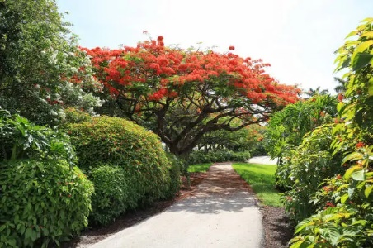

*Sunday, September 21, 2024*

**Welcome** **& Announcements** Phil Morgan

**Greeting of the Fellowship**

**Prelude** Jaci Greig

**\*Gathering Hymn** *All Creatures of Our God and King**#63*

*( Verses 1, 2, & 5)*

**\*Call to Worship** Phil Morgan

*Leader: Happy are those who do not follow the advice of the wicked,*

**People: Or take the path that sinners tread, or sit in the seat of scoffers;**

*Leader: But their delight is in the law of the Lord,*

**People: And on his law they meditate day and night.**

*Leader: They are like trees planted by streams of water,*

**People: Which yield their fruit in its season,**

*Leader: And their leaves do not wither.*

**People: In all that they do, they prosper.**

**\*Invocation & Lord’s Prayer** (We use “sins”) Phil Morgan

**Hymn** *As the Deer #548*

**Scripture Reading***Jeremiah 11:18-20* Phil Morgan

One: Hear what God is saying to the people

**Many: Thanks be to God!**

**Worship Prayer**  Pastor Dianna Cline

**Prayer Song** *Cares Chorus*

**Prayer** (During the prayer you will have the opportunity to call out concerns and praises)

**\*Hymn** *The Trees of the Field #764*

**Scripture Reflection** *Psalm 1*  Pastor Dianna Cline

***“What kind of Tree are You?”***

**\*Hymn of Response** *It is Well with my Soul #705*

**Invitation to Respond** Phil Morgan

**Offertory** Jaci Greig **\*Doxology**

**\*Prayer** Phil Morgan

If you are seeking bap'sm, to become a member at New Bethel, or would like someone to pray

with you, you are invited to come forward during this hymn.

If you are seeking bap'sm, to become a member at New Bethel, or would like someone to pray

with you, you are invited to come forward during this hymn.

**Benediction**  Pastor Dianna Cline

**Postlude** Jaci Greig

**CONTACT INFORMATION**

New Bethel Baptist Church **Website:** www.newbethelbapt.org

8936 Southeastern Avenue **E-mail:** newbethelbapt@att.net Indianapolis, IN 46239 **Wi-fi password:** NBBC8624381

317-862-4381

**Worship Music Copyright and Live-Streaming Permissions**

All selections ©1997 Word/Integrity Used by Permission.

CCLI License #1631733

Live-Streaming: CCS, WorshipCast, License #10868