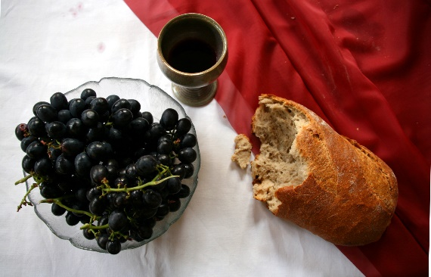

*Sunday, October 6th, 2024*

**Welcome** **& Announcements** Phil Morgan

**Greeting of the Fellowship**

**Prelude** Jaci Greig

**\*Gathering Hymn**  *We Have Come into His House #224*

**\*Call to Worship** Phil Morgan

*Leader: Holy God, untamed by the names we give you,*

**People: Come and meet us.**

*Leader: God of creation, whose hands shaped mud into your likeness,*

**People: Come and meet us.**

*Leader: Persistent God, touching and molding us still,*

**People: Come and meet us.**

*Leader: Tender God, who is forming us into a sign of the new community,*

**People: We are here to meet you.**

**.**

**\*Invocation & Lord’s Prayer** (We use “sins”) Phil Morgan

**Hymn** *All Hail the Power of Jesus’ Name #16*

**Scripture Reading** *Psalm 8* Phil Morgan

One: Hear what God is saying to the people

**Many: Thanks be to God!**

**Worship Prayer**  Pastor Dianna Cline

**Prayer Song** *Cares Chorus*

**Prayer** (During the prayer you will have the opportunity to call out concerns and praises)

**\*Hymn** *His Name is Wonderful #118*

**Scripture Reflection** Hebrews 1:1-4; 2:5-12 Pastor Dianna Cline

***“Remembering to whom we are related?”***

**\*Hymn of Response** *Jesus Your Name #119*

**Invitation to Respond** Phil Morgan

**Offertory** Jaci Greig **\*Doxology**

**\*Prayer** Phil Morgan

If you are seeking bap'sm, to become a member at New Bethel, or would like someone to pray

with you, you are invited to come forward during this hymn.

If you are seeking bap'sm, to become a member at New Bethel, or would like someone to pray

with you, you are invited to come forward during this hymn.

**Communion Hymn** *We Remember You #459*

**We Gather at the Communion Table** Pastor Dianna and Deacons

**Benediction Hymn** Blest Be the Tie

**Benediction**  Pastor Dianna Cline

**Postlude** Jaci Greig

**CONTACT INFORMATION**

New Bethel Baptist Church **Website:** www.newbethelbapt.org

8936 Southeastern Avenue **E-mail:** newbethelbapt@att.net Indianapolis, IN 46239 **Wi-fi password:** NBBC8624381

317-862-4381

**Worship Music Copyright and Live-Streaming Permissions**

All selections ©1997 Word/Integrity Used by Permission.

CCLI License #1631733

Live-Streaming: CCS, WorshipCast, License #10868