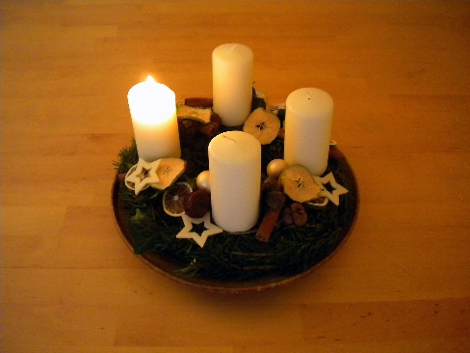  
*First Sunday of Advent, December 1st, 2024*

**Welcome** **& Announcements** Phil Morgan

**Greeting of the Fellowship**

**Prelude** Mary Collins

**\*Gathering Hymn** *O Come, O Come, Emmanuel #245*

**Advent Reading and Candle Lighting** Pastor Dianna Cline and Steve Cline

**Lord’s Prayer** (We use “sins”)

**Hymn**  *Come, Thou Long-Expected Jesus #244*

**Scripture Reading** Psalm 25:1-10 Phil Morgan

One: Hear what God is saying to the people

**Many: Thanks be to God!**

**Worship Prayer**  Pastor Dianna Cline

**Prayer Song** *Cares Chorus*

**Prayer** (During the prayer you will have the opportunity to call out concerns and praises)

**\*Hymn** *Have Faith in God #536*

**Scripture Reflection** 1 Thessalonians 3:9-13 Pastor Dianna Cline

***“Choosing the right Path”***

**\*Hymn of Response** *I offer my life  #663*

**Invitation to Respond** Phil Morgan

**Offertory** Mary Collins **\*Doxology**

**\*Prayer** Phil Morgan

If you are seeking bap'sm, to become a member at New Bethel, or would like someone to pray

with you, you are invited to come forward during this hymn.

If you are seeking bap'sm, to become a member at New Bethel, or would like someone to pray

with you, you are invited to come forward during this hymn.

**\*Communion Hymn** *Come to the Table #464*

**\*Communion Litany**

Pastor:  The peace of the Lord be with you.

**People:   And also with you.**

Pastor:   Lift up your hearts.

**People:   We lift them up to the Lord.**

Pastor:   Let us give thanks to the Lord our God.

**People:   It is right to give God thanks and praise.**

**We Gather at the Communion Table** Pastor Dianna and Deacons

**Benediction Hymn** Blest Be the Tie

**Benediction**  Pastor Dianna Cline

**Postlude** Mary Collins

This week’s ushers: Patrick Lynch and Donna Carnes

Deacons serving this week: Ruth Ann Mills and Jim Winton

**CONTACT INFORMATION**

New Bethel Baptist Church **Website:** www.newbethelbapt.org

8936 Southeastern Avenue **E-mail:** newbethelbapt@att.net Indianapolis, IN 46239 **Wi-fi password:** NBBC8624381

317-862-4381

**Worship Music Copyright and Live-Streaming Permissions**

All selections ©1997 Word/Integrity Used by Permission.

CCLI License #1631733

Live-Streaming: CCS, WorshipCast, License #10868