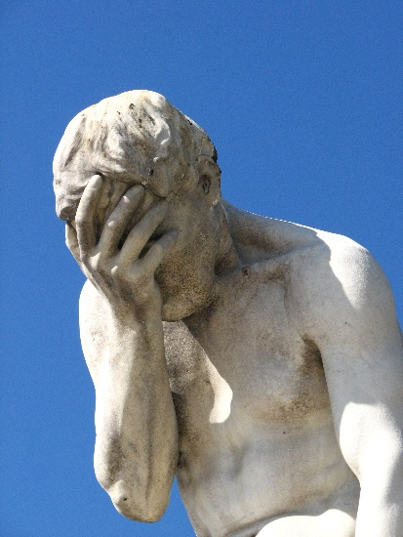

*Fourth Sunday of Advent, December 23rd, 2024*

**Welcome** **& Announcements** Phil Morgan

**Greeting of the Fellowship**

**Prelude** Jaci Greig

**\*Gathering Hymn** *Hark The Herald Angels Sing #277*

**Advent Reading and Candle Lighting** Greg West & Patrick Lynch

**Lord’s Prayer** (We use “sins”)

**Hymn**  *Angels we have heard on high #278*

**Scripture Reading**  *Luke 1:46b-55*  Phil Morgan

One: Hear what God is saying to the people

**Many: Thanks be to God!**

**Worship Prayer**  Pastor Dianna Cline

**Prayer Song** *Cares Chorus*

**Prayer** (During the prayer you will have the opportunity to call out concerns and praises)

**\*Hymn** *Infant Holy, Infant Lowly #279*

**Scripture Reflection** Luke 1:39-45 (46-55) Pastor Dianna Cline

***“Why Me? Vs. Why Not Me?”***

**\*Hymn of Response** *O Little Town of Bethlehem #250*

**Invitation to Respond**  Pastor Dianna Cline

**Offertory** Go Tell it on the Mountain NBBC Choir

**\*Doxology**

**\*Prayer** Phil Morgan

If you are seeking bap'sm, to become a member at New Bethel, or would like someone to pray

with you, you are invited to come forward during this hymn.

If you are seeking bap'sm, to become a member at New Bethel, or would like someone to pray

with you, you are invited to come forward during this hymn.

**Benediction**  Pastor Dianna Cline

**Postlude** Jaci Greig

This week’s ushers: Carol Lucas and Liz Ballard

**CONTACT INFORMATION**

New Bethel Baptist Church **Website:** www.newbethelbapt.org

8936 Southeastern Avenue **E-mail:** newbethelbapt@att.net Indianapolis, IN 46239 **Wi-fi password:** NBBC8624381

317-862-4381



**Worship Music Copyright and Live-Streaming Permissions**

All selections ©1997 Word/Integrity Used by Permission.

CCLI License #1631733

Live-Streaming: CCS, WorshipCast, License #10868