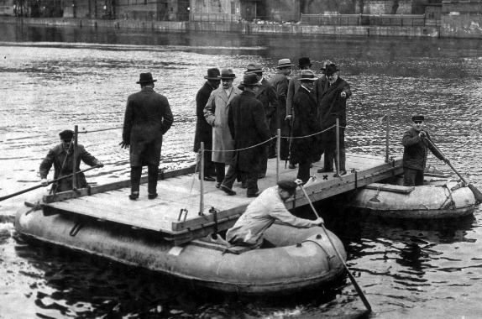  
*Sunday, January 12th, 2025*

**Welcome** **& Announcements** Phil Morgan

**Greeting of the Fellowship**

**Prelude** Jaci Greig

**\*Gathering Hymn** *Majesty #10*

**\*Call to Worship** Phil Morgan

*Leader: Who is the Lord?***People: “I AM” is the Lord, the Holy One of Israel.***Leader: Who is the Lord?***People: “I AM” is our Savior, our God, our rock and our fortress.***Leader: Who is the Lord?***People: “I AM” is our redeemer, our deliverer and guide.***Leader: Who is the Lord?***People: “I AM” is the one who calls us and sends us.  
All: We have nothing to fear. “I AM” is with us!**

**\*Invocation & Lord’s Prayer** (We use “sins”) Phil Morgan

**Hymn** *All Hail the Power of Jesus’ Name #16*

**Scripture Reading** *Psalm 29* Phil Morgan

One: Hear what God is saying to the people

**Many: Thanks be to God!**

**Worship Prayer**  Pastor Dianna Cline

**Prayer Song** *Cares Chorus*

**Prayer** (During the prayer you will have the opportunity to call out concerns and praises)

**\*Hymn**  *Precious Lord, Take My Hand #684*

**Scripture Reflection** *Isaiah 43: 1-7*  Pastor Dianna Cline

***“Do you have your SeaPass?***

**\*Hymn of Response** *Eternal Father, Strong to Save #808*

*(This is a time to come forward to join the church, rededicate your life, or be baptized)*

**Invitation to Respond**  Phil Morgan

**Offertory**

**\*Doxology**

**\*Prayer**  Phil Morgan

If you are seeking bap'sm, to become a member at New Bethel, or would like someone to pray

with you, you are invited to come forward during this hymn.

If you are seeking bap'sm, to become a member at New Bethel, or would like someone to pray

with you, you are invited to come forward during this hymn.

**Benediction**  Pastor Dianna Cline

**Postlude** Jaci Greig

Ushers serving this week: Jeannine Toon and Sherry Shoemaker

**CONTACT INFORMATION**

New Bethel Baptist Church **Website:** www.newbethelbapt.org

8936 Southeastern Avenue **E-mail:** newbethelbapt@att.net Indianapolis, IN 46239 **Wi-fi password:** NBBC8624381

317-862-4381

**Worship Music Copyright and Live-Streaming Permissions**

All selections ©1997 Word/Integrity Used by Permission.

CCLI License #1631733

Live-Streaming: CCS, WorshipCast, License #10868