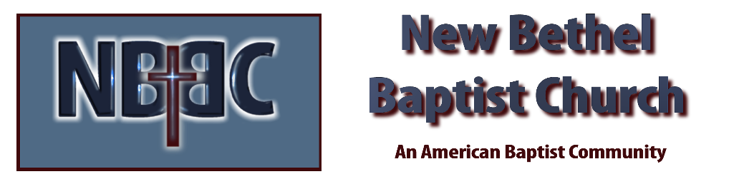

Sunday, March 9th, 2025

Welcome & Announcements Phil Morgan
Greeting of the Fellowship
Prelude Jaci Greig
*Gathering Hymn When Morning Gilds the Skies #215
*Call to Worship Phil Morgan
One: The season rolls around again.
All: Deep calls to deep.
One: Settle down. Look within.
All: Be quiet. Listen.
One: Are you on the right path? Are you drawing closer to God? Are you more loving?
All: Now is the time to reflect and pray.
One: Now is the season for silence and giving.
All: Thank God for Lent.
One: Thank God we journey not alone.
*Invocation & Lord’s Prayer (We use “sins”) Phil Morgan

Hymn I’ll Tell the World That I’m a Christian #448

Scripture Reading Romans 10:8-13 Phil Morgan
One: Hear what God is saying to the people
Many: Thanks be to God!

Worship Prayer Pastor Dianna Cline
Prayer Song Cares Chorus
Prayer (During the prayer you will have the opportunity to call out concerns and praises)

*Hymn Come Thou Fount of Ev’ry Blessing #11

Scripture Reflection Deuteronomy 26:1-11 Pastor Dianna Cline
“Are you giving or giving up?”

*Hymn of Response We Give Thee But Thine Own #816
(This is a time to come forward to join the church, rededicate your life, or be baptized)

Invitation to Respond Phil Morgan

Offertory
*Doxology
*Prayer Pastor Dianna Cline
If you are seeking bap'sm, to become a member at New Bethel, or would like someone to pray
with you, you are invited to come forward during this hymn.
If you are seeking bap'sm, to become a member at New Bethel, or would like someone to pray
with you, you are invited to come forward during this hymn.

Diminishing Lights Reading Phil Morgan
Benediction Pastor Dianna Cline
Postlude Jaci Greig

CONTACT INFORMATION
New Bethel Baptist Church Website: www.newbethelbapt.org
8936 Southeastern Avenue E-mail: newbethelbapt@att.net Indianapolis, IN 46239 Wi-fi password: NBBC8624381
317-862-4381
Worship Music Copyright and Live-Streaming Permissions
All selections ©1997 Word/Integrity Used by Permission.
CCLI License #1631733

Live-Streaming: CCS, WorshipCast, License #10868

