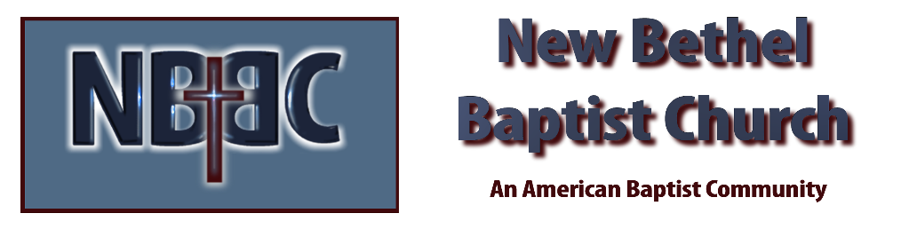

Sunday, March 16th, 2025

Welcome & Announcements Phil Morgan
Greeting of the Fellowship
Prelude Jaci Greig
*Gathering Hymn We Have Come Into His House #224
*Call to Worship Phil Morgan
One: Lord God, be with us this Sabbath day, as we continue our Lenten journey.
Many: As we hear your word and sing praises in song,
One: Settle down. Look within.
Many: Be quiet. Listen.
One: May we celebrate and give thanks for God’s wondrous mercies.
Many: As we share in fellowship, focus in prayer,
One: May we grow in discipleship and come to know the hope and promise
Many: Of the cross of Jesus Christ our Lord.
One: Prepare us now for this time of worship,
All: And may the power and promise of our Lord Jesus Christ be with us.
*Invocation & Lord’s Prayer (We use “sins”) Phil Morgan

Hymn Wonderful Grace of Jesus #338

Scripture Reading Psalm 27 Phil Morgan
One: Hear what God is saying to the people
Many: Thanks be to God!

Worship Prayer Pastor Dianna Cline
Prayer Song Cares Chorus
Prayer (During the prayer you will have the opportunity to call out concerns and praises)

*Hymn Amazing Grace #343

Scripture Reflection Philippians 3:17-4:1 Pastor Dianna Cline
“A User-Friendly Faith”

*Hymn of Response By His Grace #339
(This is a time to come forward to join the church, rededicate your life, or be baptized)

Invitation to Respond Phil Morgan

Offertory Standing on the Promises NBBC Choir
*Doxology
*Prayer Pastor Dianna Cline
If you are seeking bap'sm, to become a member at New Bethel, or would like someone to pray
with you, you are invited to come forward during this hymn.
If you are seeking bap'sm, to become a member at New Bethel, or would like someone to pray
with you, you are invited to come forward during this hymn.

Diminishing Lights Reading Steve Cline
Benediction Pastor Dianna Cline
Postlude
Jaci Greig
Lay Leader: Phil Morgan
Pianist: Jaci Greig
Today’s Ushers: Patty Damman & Pat Morgan

CONTACT INFORMATION
New Bethel Baptist Church Website: www.newbethelbapt.org
8936 Southeastern Avenue E-mail: newbethelbapt@att.net Indianapolis, IN 46239 Wi-fi password: NBBC8624381
317-862-4381
Worship Music Copyright and Live-Streaming Permissions
All selections ©1997 Word/Integrity Used by Permission.
CCLI License #1631733

Live-Streaming: CCS, WorshipCast, License #10868

