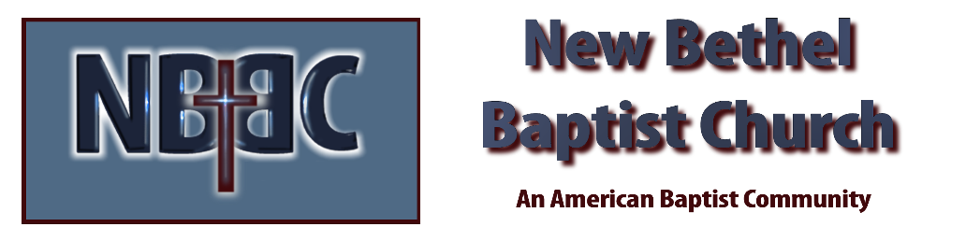

Sunday, March 23rd, 2025

Welcome & Announcements Phil Morgan
Greeting of the Fellowship
Prelude Christina Romero
*Gathering Hymn We Have Come to Join in Worship #207
*Call to Worship Phil Morgan
One: Come, sisters and brothers, gather.
Many: Plunge your sorrows and worries into the fountain of life; find healing and comfort.
One: Place your dreams and hopes on the table of blessing; find strength and hope.
Many: Come, you thirsty and weary, come from hard journeys and busy days and incline your ear to our Sabbath God, who says, come away and rest a while.
One: Come, you hungry and longing, find here the bread of life, the words of truth, the fellowship of renewal.
Many: Everyone who thirsts, come to the waters.
One: Everyone who hungers, come to the source.
Many: Come with excitement and hope.
One: Come, find delight and new life.
All: Amen
*Invocation & Lord’s Prayer (We use “sins”) Phil Morgan

Hymn Just As I Am #488
Scripture Reading Psalm 63:1-8 Phil Morgan
One: Hear what God is saying to the people
Many: Thanks be to God!

Worship Prayer Pastor Dianna Cline
Prayer Song Cares Chorus
Prayer (During the prayer you will have the opportunity to call out concerns and praises)

*Hymn Jesus I Come #491
Scripture Reflection Isaiah 55:1-9 Pastor Dianna Cline
“A New Economy”

*Hymn of Response Come, Ye Sinners, Poor and Needy #486
(This is a time to come forward to join the church, rededicate your life, or be baptized)

Invitation to Respond Phil Morgan

Offertory Christina Romero
*Doxology
*Prayer Pastor Dianna Cline
If you are seeking bap'sm, to become a member at New Bethel, or would like someone to pray
with you, you are invited to come forward during this hymn.
If you are seeking bap'sm, to become a member at New Bethel, or would like someone to pray
with you, you are invited to come forward during this hymn.

Diminishing Lights Reading Pat Morgan
Benediction Pastor Dianna Cline
Postlude Christina Romero

Lay Leader: Phil Morgan
Pianist: Christina Romero
Today’s Ushers: Liz Ballard and Greg West

CONTACT INFORMATION
New Bethel Baptist Church Website: www.newbethelbapt.org
8936 Southeastern Avenue E-mail: newbethelbapt@att.net Indianapolis, IN 46239 Wi-fi password: NBBC8624381
317-862-4381
Worship Music Copyright and Live-Streaming Permissions
All selections ©1997 Word/Integrity Used by Permission.
CCLI License #1631733

Live-Streaming: CCS, WorshipCast, License #10868

