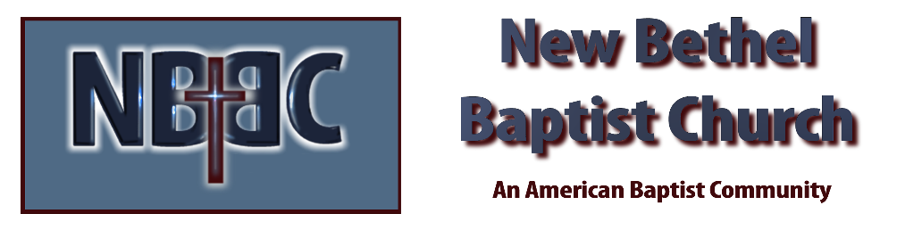

Sunday, April 6th, 2025

Welcome & Announcements Phil Morgan
Greeting of the Fellowship
Prelude Jaci Greig
*Gathering Hymn To God Be the Glory #56
*Call to Worship Phil Morgan
One: In these 40 days, you lead us into the desert of repentance, that in this pilgrimage of prayer we might learn to be your people once more. In fasting and service, you bring us back to your heart.
Many: You open our eyes to your presence in the world, and you free our hands to lead others to the radiant splendor of your mercy.
One: Be with us in these journey days, for without you we are lost and will perish.
All: To you alone be dominion and glory, forever and ever. Amen.
*Invocation & Lord’s Prayer (We use “sins”) Phil Morgan
Hymn Glorify Thy Name #9
Scripture Reading Isaiah 43:16-21 Phil Morgan
One: Hear what God is saying to the people
Many: Thanks be to God!

Worship Prayer Pastor Dianna Cline
Prayer Song Cares Chorus
Prayer (During the prayer you will have the opportunity to call out concerns and praises)

*Hymn When I Survey the Wondrous Cross #324

Scripture Reflection Philippians 3:4b-14 Pastor Dianna Cline
“I Triple Dog Dare You!”

*Hymn of Response Since Jesus Came into My Heart #503
(This is a time to come forward to join the church, rededicate your life, or be baptized)

Invitation to Respond Phil Morgan

Offertory Jaci Greig
*Doxology
*Prayer Pastor Dianna Cline
If you are seeking bap'sm, to become a member at New Bethel, or would like someone to pray
with you, you are invited to come forward during this hymn.
If you are seeking bap'sm, to become a member at New Bethel, or would like someone to pray
with you, you are invited to come forward during this hymn.

Diminishing Lights Reading Adrianne Hunter
Communion Hymn In Remembrance #461
Communion
Benediction Hymn Blest Be the Tie That Binds
Postlude Jaci Greig

Lay Leader: Phil Morgan
Pianist: Jaci Greig
Today’s Ushers: Donna Carnes & Patrick Lynch
Deacons Serving Communion: Phil Morgan & Adrianne Hunter

CONTACT INFORMATION
New Bethel Baptist Church Website: www.newbethelbapt.org
8936 Southeastern Avenue E-mail: newbethelbapt@att.net Indianapolis, IN 46239 Wi-fi password: NBBC8624381
317-862-4381
Worship Music Copyright and Live-Streaming Permissions
All selections ©1997 Word/Integrity Used by Permission.
CCLI License #1631733

Live-Streaming: CCS, WorshipCast, License #10868

