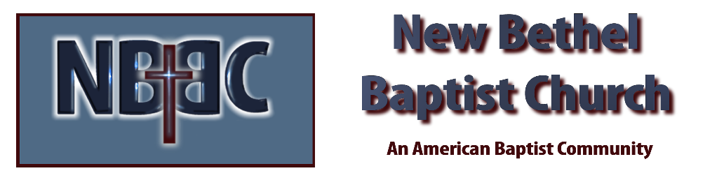

Sunday, April 6th, 2025

Welcome & Announcements Phil Morgan
Greeting of the Fellowship
Prelude Jaci Greig
*Gathering Hymn Hosanna, Loud Hosanna #297
*Call to Worship Phil Morgan
All: Merciful Savior, it is our privilege and delight to be in your presence and to bring our praises and worship to you. You are our teacher and friend, our rock and hope, and our strength and light. We celebrate your arrival in Jerusalem; we anticipate the agony that is before you; we await your victory over death. Grant that we might walk this journey alongside you as faithful disciples, rather than as participants of the fickle crowd. Let us join together in the Prayer that Jesus taught us…
*Lord’s Prayer (We use “sins”) Phil Morgan
Hymn All Glory Laud and Honor #300
Scripture Reading Luke 19:28-40 Phil Morgan
One: Hear what God is saying to the people
Many: Thanks be to God!

Worship Prayer Pastor Dianna Cline
Prayer Song Cares Chorus
Prayer (During the prayer you will have the opportunity to call out concerns and praises)

*Hymn We Will Glorify #301
^{(Sing two times)}
Scripture Reflection Luke 19:28-40 Pastor Dianna Cline
“From Triumph to Tragedy”

*Hymn of Response Room at the Cross for You #487
(This is a time to come forward to join the church, rededicate your life, or be baptized)

Invitation to Respond Phil Morgan

Offertory “Gethsemane” Kevin Stone & Jaci Greig
*Doxology
*Prayer Pastor Dianna Cline
If you are seeking bap'sm, to become a member at New Bethel, or would like someone to pray
with you, you are invited to come forward during this hymn.
If you are seeking bap'sm, to become a member at New Bethel, or would like someone to pray
with you, you are invited to come forward during this hymn.

Diminishing Lights Reading
Benediction
Postlude Jaci Greig

Lay Leader: Phil Morgan
Pianist: Jaci Greig
Today’s Ushers: Jeannine Toon & Sherry Shoemaker

CONTACT INFORMATION
New Bethel Baptist Church Website: www.newbethelbapt.org
8936 Southeastern Avenue E-mail: newbethelbapt@att.net Indianapolis, IN 46239 Wi-fi password: NBBC8624381
317-862-4381
Worship Music Copyright and Live-Streaming Permissions
All selections ©1997 Word/Integrity Used by Permission.
CCLI License #1631733

Live-Streaming: CCS, WorshipCast, License #10868

