Welcome to New Bethel Baptist Church
Sunday May 25th, 2025

Welcome & Announcements Phil Morgan
Greeting of the Fellowship
Prelude Jaci Greig
*Gathering Hymn We Have Come to Join in Worship #207

*Call to Worship Phil Morgan
One: Hear what the Lord requires of members in the family of God:
All: To do justice, love kindness, and walk humbly with your God.
One: Hear what Jesus taught about participation in the kingdom of God:
All: Love the Lord your God with all your heart, all your soul, all your mind and all your strength; and love your neighbor as yourself. One: Let us be true to our calling to follow Christ.

*Invocation and Lord’s Prayer (We use “sins”) Phil Morgan
Hymn Come Christians Join to Sing #225

Scripture Reading Psalm 67 Phil Morgan
One: Hear what God is saying to the people
Many: Thanks be to God!

Worship Prayer Pastor Dianna Cline
Prayer Song Cares Chorus
Prayer (During the prayer you will have the opportunity to call out concerns and praises

*Hymn Send the Light #437

Scripture Reflection Acts 16:9-15 Pastor Dianna Cline
“Changing Plans”

*Hymn of Response Jesus Saves #438
(This is a time to come forward to join the church, rededicate your life, or be baptized)

Invitation to Respond Phil Morgan
Offertory Jaci Greig
*Doxology
*Prayer Pastor Dianna Cline
If you are seeking bap'sm, to become a member at New Bethel, or would like someone to pray
with you, you are invited to come forward during this hymn.
If you are seeking bap'sm, to become a member at New Bethel, or would like someone to pray
with you, you are invited to come forward during this hymn.

Benediction Pastor Dianna Cline
Postlude Jaci Greig

Lay Leader: Phil Morgan
Pianist: Jaci Greig
Today’s Ushers: Liz Ballard and Greg West

CONTACT INFORMATION
New Bethel Baptist Church Website: www.newbethelbapt.org
8936 Southeastern Avenue E-mail: newbethelbapt@att.net
Indianapolis, IN 46239 Wi-fi password: NBBC8624381
317-862-4381

Worship Music Copyright and Live-Streaming Permissions
All selections ©1997 Word/Integrity Used by Permission.
CCLI License #1631733

Live-Streaming: CCS, WorshipCast, License #10868

Church Covenant
ARTICLE IV
We, the members of this church, having experienced the grace of
God the Father, confessing Jesus Christ as Savior and Lord, relying
on the guidance of His Spirit, and accepting the Holy Scriptures as
the rule of faith and practice, joyfully and solemnly covenant:
That we will regularly participate in public worship and loyally
support the total ministry of our church;
That, mindful of the teachings of our Savior, we will walk together
in brotherly love; be slow to take offense, but always be ready for
reconciliation, and seek it without delay; that we will exercise a
Christian care and concern over each other; participate in each other’s
joys and sorrows, and with tender sympathy bear one another’s burdens
and so fulfill the law of Christ;
That we will live temperately, be just in our dealings, faithful
in our engagements; and do unto others as we would have them do
unto us.
That we will maintain personal and family devotions and provide
Christian education for the children committed to our care;
That we will willingly practice the stewardship of our substance,
our time and our lives for the support of the church and the
building of God’s kingdom;
That in keeping Christ’s Great Commission, “Go ye therefore and
make disciples of all nations” we will give ourselves to the spread
of the gospel over the earth; and will use every opportunity of
word and example to bring our kindred and acquaintance to the
knowledge of Jesus Christ.
That upon our removal from this community, we will as soon as possible
units with a church where we can carry out the spirit of this
covenant with humble faith in the help of God.
We accept this Covenant with the earnest prayer that we may hold
fast our Christian profession, keep the faith, and so live that we
may be fitly prepared for life eternal, which is our hope in Christ
Jesus. Amen.
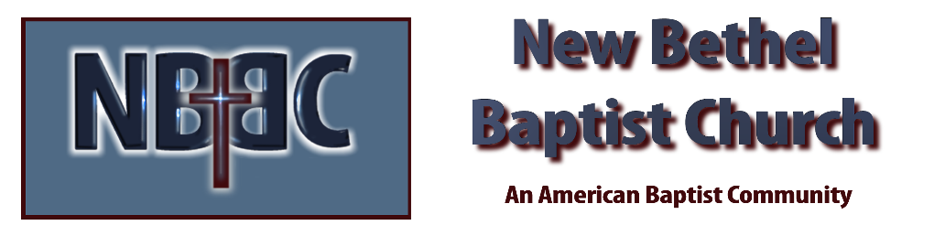

Sunday, May 25th, 2025



