Welcome to New Bethel Baptist Church
Sunday June 8th, 2025

Welcome & Announcements Phil Morgan
Greeting of the Fellowship
Prelude Jaci Greig
*Gathering Hymn All creatures of Our God and King #63

*Call to Worship and Lord’s Prayer Phil Morgan
Leader: Be the light, bearing it to All the world.
All: No Hiding
Leader: Be the light, sharing it with All you encounter.
All: No Staling.
Leader: Be the light, so that our neighbors can find their way
All: No Holding Back
Leader: Be the light, so that the world will know there is a path forward.
All: No Hiding, No Stalling, No Holding. We move forward to be the light.

*Invocation and Lord’s Prayer
Mission Moment for One Great Hour of Sharing John Huddleston

Hymn Shine Jesus Shine #431

Scripture Reading Acts 2:1-21 Phil Morgan
Leader: Hear what God is saying to the people
Many: Thanks be to God!

Worship Prayer Pastor Dianna Cline
Prayer Song Cares Chorus
Prayer (During the prayer you will have the opportunity to call out concerns and praises

*Hymn Holy Spirit, Light Divine #392

Scripture Reflection Romans: 8:14-17 Pastor Dianna Cline
“Pentecostal Power”
*Litany of Responsive Reading Phil Morgan
Leader: When communities are in crisis,
All: Be the light.
Leader: When tornados devastate the countryside,
All: Be the light.
Leader: When human beings are mistreated,
All: Be the light.
Leader: When the earth is abused and creation is disrespected,
All: Be the light.
Leader: When justice is denied,
All: Be the light.
Leader: When another is in need,
All: Be the light.
Leader: Light-bearers you are,
All: We will be the light.
Leader: Go public. Find a hilltop.
All: We will be the light.
(This is a time to come forward to join the church, rededicate your life, or be baptized)
Invitation to Respond Phil Morgan
Offertory Jaci Greig
*Doxology
*Prayer Pastor Dianna Cline
If you are seeking bap'sm, to become a member at New Bethel, or would like someone to pray
with you, you are invited to come forward during this hymn.
If you are seeking bap'sm, to become a member at New Bethel, or would like someone to pray
with you, you are invited to come forward during this hymn.
Benediction Pastor Dianna Cline
Postlude Jaci Greig
Lay Leader: Phil Morgan
Pianist: Jaci Greig
Today’s Ushers: Jeannine Toon and Sherry Shoemaker
CONTACT INFORMATION
New Bethel Baptist Church Website: www.newbethelbapt.org
8936 Southeastern Avenue E-mail: newbethelbapt@att.net
Indianapolis, IN 46239 Wi-fi password: NBBC8624381
317-862-4381
Worship Music Copyright and Live-Streaming Permissions
All selections ©1997 Word/Integrity Used by Permission.
CCLI License #1631733
Live-Streaming: CCS, WorshipCast, License #10868

Purpose Statement

New Bethel Baptist Church exists for the purpose of serving God in the following ways:
- Worshipping as a community of faith in Jesus Christ.
- Instruction in developing a closer relationship with God.
- Fellowship with other believers.
- Evangelism as sharing the good news with our neighbors near and far.
- Service in our church community to honor God.

Vision Statement

The vision of New Bethel Baptist Church is to be a fellowship where everyone can worship, learn, and serve in an accepting community of believers.

Our vision will be lived out through our core values

1. Acceptance
Accepting all God’s children

2. Family
Ministering through Christian Education for all ages
Spiritual gifts and Christian Love
Growing as a family

3. Compassion
Providing care and support
Sharing the Good News locally and globally

4. Spiritual Growth
Discovery of spiritual gifts
Understanding God’s purpose

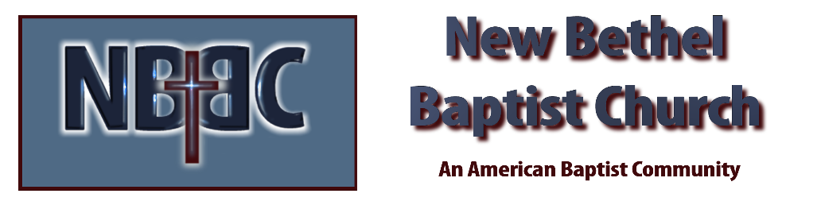

Sunday, June 8th, 2025



