Welcome to New Bethel Baptist Church
Sunday June 15th, 2025

Welcome & Announcements Phil Morgan
Greeting of the Fellowship
Prelude Jaci Greig
*Gathering Hymn We Have Come to Join in Worship #207

*Call to Worship and Lord’s Prayer Phil Morgan
Leader: Again, we gather.
People: Again, we sing.
Leader: Again, we read and hear and pray.
People: We do these things again and again because we believe God is in them.
Leader: We believe God desires our worship. We believe God wants to speak to us. So, as we come together again, let us do so with great expectation.
People: Let us lay aside what we think we know and open ourselves up to the miraculous.
Leader: Let us worship again the God who loves us,
People: who redeemed us,
Leader: who will one day return to us.
All: Come, now and worship.

*Invocation and Lord’s Prayer
Hymn Majesty #10

Scripture Reading Psalm 8 Phil Morgan
Leader: Hear what God is saying to the people
Many: Thanks be to God!

Worship Prayer Pastor Dianna Cline
Prayer Song Cares Chorus
Prayer (During the prayer you will have the opportunity to call out concerns and praises

*Hymn Holy, Holy, Holy! Lord God Almighty #3

Scripture Reflection John 16:12-15 Pastor Dianna Cline
“The Trinity”

*Hymn of Response Come, Thou Almighty King #8
(This is a time to come forward to join the church, rededicate your life, or be baptized)

Invitation to Respond Phil Morgan
Offertory Jaci Greig
*Doxology
*Prayer Pastor Dianna Cline

If you are seeking bap'sm, to become a member at New Bethel, or would like someone to pray
with you, you are invited to come forward during this hymn.
If you are seeking bap'sm, to become a member at New Bethel, or would like someone to pray
with you, you are invited to come forward during this hymn.
Benediction Pastor Dianna Cline
Postlude Jaci Greig

Lay Leader: Phil Morgan
Pianist: Jaci Greig
Today’s Ushers: Patty Dammann and Pat Morgan

CONTACT INFORMATION
New Bethel Baptist Church Website: www.newbethelbapt.org
8936 Southeastern Avenue E-mail: newbethelbapt@att.net
Indianapolis, IN 46239 Wi-fi password: NBBC8624381
317-862-4381

Worship Music Copyright and Live-Streaming Permissions
All selections ©1997 Word/Integrity Used by Permission.
CCLI License #1631733

Live-Streaming: CCS, WorshipCast, License #10868

Purpose Statement

New Bethel Baptist Church exists for the purpose of serving God in the following ways:
- Worshipping as a community of faith in Jesus Christ.
- Instruction in developing a closer relationship with God.
- Fellowship with other believers.
- Evangelism as sharing the good news with our neighbors near and far.
- Service in our church community to honor God.

Vision Statement

The vision of New Bethel Baptist Church is to be a fellowship where everyone can worship, learn, and serve in an accepting community of believers.

Our vision will be lived out through our core values

1. Acceptance
Accepting all God’s children

2. Family
Ministering through Christian Education for all ages
Spiritual gifts and Christian Love
Growing as a family

3. Compassion
Providing care and support
Sharing the Good News locally and globally

4. Spiritual Growth
Discovery of spiritual gifts
Understanding God’s purpose

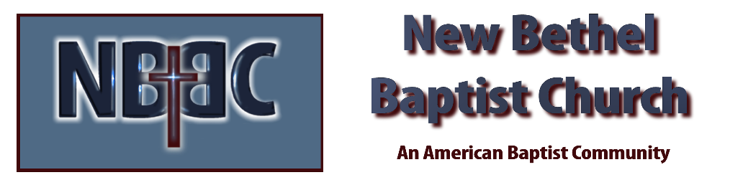

Sunday, June 15th, 2025

