Welcome to New Bethel Baptist Church
Sunday June 22, 2025

Welcome & Announcements Kevin Stone
Greeting of the Fellowship
Prelude Jaci Greig
*Gathering Hymn We Have Come to Join in Worship #207

*Call to Worship Kevin Stone
Leader: Gathered here are the people of God,
People: who come to sing praise and seek guidance for the lives we live.
Leader: Gathered here are the people of God,
People: who come in joy and sorrow, in peace and despair.
Leader: Gathered here are the people of God,
People: who come in thanksgiving and regret, in hope and grief.
All: We are the people of God! We give gratitude for this day, which will not dawn again. Let us lift our voices in praise and thanksgiving.

*Invocation and Lord’s Prayer

Hymn Praise Him! Praise Him! #12

Scripture Reading Psalm 22:19-28 Kevin Stone
One: Hear what God is saying to the people
Many: Thanks be to God!

Worship Prayer Pastor Dianna Cline
Prayer Song Cares Chorus
Prayer (During the prayer you will have the opportunity to call out concerns and praises

*Hymn Dear Lord and Father of Mankind #639

Scripture Reflection 1 Kings 19:1-15 Pastor Dianna Cline
Are you in narcissistic funk?

*Hymn of Response Take My Life and Let it be Consecrated #597
(This is a time to come forward to join the church, rededicate your life, or be baptized)

Invitation to Respond Kevin Stone
Offertory Jaci Greig
*Doxology
*Prayer Pastor Dianna Cline

If you are seeking bap'sm, to become a member at New Bethel, or would like someone to pray
with you, you are invited to come forward during this hymn.
If you are seeking bap'sm, to become a member at New Bethel, or would like someone to pray
with you, you are invited to come forward during this hymn.
Benediction Pastor Dianna Cline
Postlude Jaci Greig

Lay Leader: Kevin Stone
Pianist: Jaci Greig
Today’s Ushers: Liz Ballard and Greg West

CONTACT INFORMATION
New Bethel Baptist Church Website: www.newbethelbapt.org
8936 Southeastern Avenue E-mail: newbethelbapt@att.net
Indianapolis, IN 46239 Wi-fi password: NBBC8624381
317-862-4381

Worship Music Copyright and Live-Streaming Permissions
All selections ©1997 Word/Integrity Used by Permission.
CCLI License #1631733

Live-Streaming: CCS, WorshipCast, License #10868

Purpose Statement

New Bethel Baptist Church exists for the purpose of serving God in the following ways:
- Worshipping as a community of faith in Jesus Christ.
- Instruction in developing a closer relationship with God.
- Fellowship with other believers.
- Evangelism as sharing the good news with our neighbors near and far.
- Service in our church community to honor God.

Vision Statement

The vision of New Bethel Baptist Church is to be a fellowship where everyone can worship, learn, and serve in an accepting community of believers.

Our vision will be lived out through our core values

1. Acceptance
Accepting all God’s children

2. Family
Ministering through Christian Education for all ages
Spiritual gifts and Christian Love
Growing as a family

3. Compassion
Providing care and support
Sharing the Good News locally and globally

4. Spiritual Growth
Discovery of spiritual gifts
Understanding God’s purpose

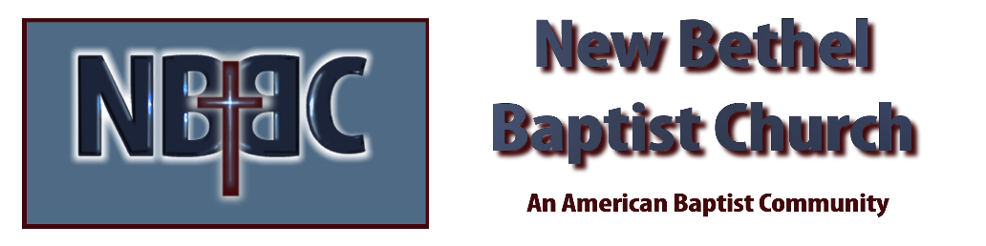

Sunday, June 22, 2025



