Welcome to New Bethel Baptist Church
Sunday July 13, 2025

Welcome & Announcements Kevin Stone
Greeting of the Fellowship

Prelude Jaci Greig
*Gathering Hymn We Have Come to Join in Worship #207 (verses 1 and 3)

*Call to Worship Kevin Stone
Leader: Lord Jesus, bind us to you and to our brothers and sisters with love.
People: May our hearts not be turned away from you and your Word. May our souls not be deceived nor our talents or minds enticed by allurements or errors, so that we may never distance ourselves from your love.
Leader: May we learn this morning to love our neighbor as ourselves with strength, wisdom and gentleness.
People: With your help, you who are blessed throughout all ages.

*Invocation and Lord’s Prayer

Hymn My Faith Looks up to Thee #539 (verses 1 and 2)

Scripture Reading Psalm 25:1-10 Kevin Stone
One: Hear what God is saying to the people
Many: Thanks be to God!

Worship Prayer Pastor Dianna Cline
Prayer Song Cares Chorus
Prayer (During the prayer you will have the opportunity to call out concerns and praises)

*Hymn Rescue the Perishing #441 (verses 1,2 and 3)

Scripture Reflection Luke 10:25-37 Pastor Dianna Cline
“Are you a Samaritan or a bystander?”

*Hymn of Response Take the Name of Jesus with You #235 (verses 1,2 and 4)
(This is a time to come forward to join the church, rededicate your life, or be baptized)

Invitation to Respond Kevin Stone
Offertory Jaci Greig
*Doxology
*Prayer Pastor Dianna Cline

If you are seeking bap'sm, to become a member at New Bethel, or would like someone to pray
with you, you are invited to come forward during this hymn.
If you are seeking bap'sm, to become a member at New Bethel, or would like someone to pray
with you, you are invited to come forward during this hymn.
Benediction Pastor Dianna Cline
Postlude Jaci Greig

Lay Leader: Kevin Stone
Pianist: Jaci Greig
Today’s Ushers: Jeannine Toon and Sherry Shoemaker

Flowers arranged for July by Melody Lynch

CONTACT INFORMATION
New Bethel Baptist Church Website: www.newbethelbapt.org
8936 Southeastern Avenue E-mail: newbethelbapt@att.net
Indianapolis, IN 46239 Wi-fi password: NBBC8624381
317-862-4381

Worship Music Copyright and Live-Streaming Permissions
All selections ©1997 Word/Integrity Used by Permission.
CCLI License #1631733

Live-Streaming: CCS, WorshipCast, License #10868

The Lord’s Prayer

Our Father in heaven,
Hallowed be Your name.
Your kingdom come.
Your will be done
On earth as it is in heaven.
Give us this day our daily bread.
And forgive us our sins,
As we forgive our sinners.
And do not lead us into temptation,
But deliver us from the evil one.
For Yours is the kingdom and the power and the glory forever. Amen.

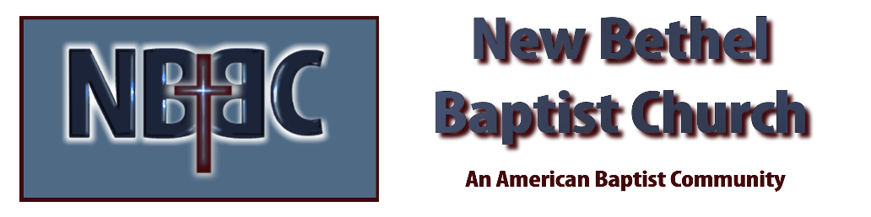

Sunday July 13, 2025

