Welcome to New Bethel Baptist Church
Sunday July 20, 2025

Welcome & Announcements Phil Morgan
Greeting of the Fellowship

Prelude Dr. Christina Romero
Blessing of the Backpacks Ruth Ann Mills

Leader: Loving God, be with these young people. Be with them and help them as they begin a new year of learning and growing.
People: May their minds and their pencils be sharp; may their lunches never be forgotten at home; and may their pink erasers help them to remember that mistakes are okay – in fact are necessary.
Leader: God, thank you for glue sticks and homework folders and laptops and crisp new notebooks waiting to be filled; thank you for schools and libraries and teachers; thank you for the gift of curiosity and for your Wisdom that is all around.
People: God of Wisdom, bless these young people and the backpacks they carry.
Leader: We pray this in the name of your Son, who left his parents so he could sit and learn at the feet of the rabbis in the Temple. And all God’s people say,
People: Amen.

*Gathering Hymn Praise to the Lord, the Almighty #210
*Call to Worship Phil Morgan
#579 in the Hymnal
*Invocation and Lord’s Prayer (We use “sins”) Phil Morgan

Hymn Tis so Sweet to Trust in Jesus #581

Scripture Reading Psalm 15 Phil Morgan
One: Hear what God is saying to the people
Many: Thanks be to God!

Worship Prayer
Prayer Song Cares Chorus
Prayer (During the prayer you will have the opportunity to call out concerns and praises)

*Hymn Trust and Obey #571
Scripture Reflection Proverbs 3:5-6 Pastor Tom Jackson
“Miracles Still Take Place”

*Hymn of Response Blessed Assurance #572
(This is a time to come forward to join the church, rededicate your life, or be baptized)

Invitation to Respond Phil Morgan
Offertory Dr. Christina Romero
*Doxology
*Prayer Pastor Tom Jackson

If you are seeking bap'sm, to become a member at New Bethel, or would like someone to pray
with you, you are invited to come forward during this hymn.
If you are seeking bap'sm, to become a member at New Bethel, or would like someone to pray
with you, you are invited to come forward during this hymn.
Benediction Pastor Tom Jackson
Postlude Dr. Christina Romero

Lay Leader: Phil Morgan
Pianist: Dr. Christina Romero
Today’s Ushers: Patty Dammann & Pat Morgan

Flowers arranged for July by Melody Lynch
A special thank you to Pastor Tom Jackson for covering the pulpit this Sunday.

CONTACT INFORMATION
New Bethel Baptist Church Website: www.newbethelbapt.org
8936 Southeastern Avenue E-mail: newbethelbapt@att.net
Indianapolis, IN 46239 Wi-fi password: NBBC8624381
317-862-4381

Worship Music Copyright and Live-Streaming Permissions
All selections ©1997 Word/Integrity Used by Permission.
CCLI License #1631733

Live-Streaming: CCS, WorshipCast, License #10868

The Lord’s Prayer

Our Father in heaven,
Hallowed be Your name.
Your kingdom come.
Your will be done
On earth as it is in heaven.
Give us this day our daily bread.
And forgive us our sins,
As we forgive our sinners.
And do not lead us into temptation,
But deliver us from the evil one.
For Yours is the kingdom and the power and the glory forever. Amen.

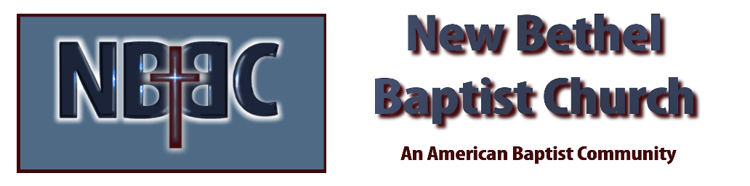

Sunday July 20, 2025



